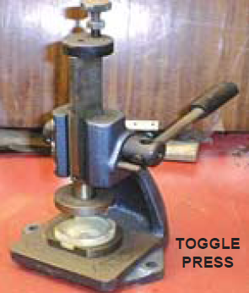
Theory of machines
Theory of machines is a subject deals with the motion and forces acting on the parts or links of a machine.
- Principle Concepts
Kinematics of motion: it is the relative motion of bodies without consideration of the forces causing the motion i.e. kinematics deals with the geometry of motion and concepts like displacement, velocity and acceleration considered as function of time.
Kinetics of motion: it is the motion which takes into consideration the forces or other factors e.g. mass or weight of the bodies.
Rectilinear motion: it is the simplest type of motion and is along a straight line path.
Curvilinear motion: it is the motion along a curved path. This motion is confined to one plane.
Rotational motion: when all the particles of a body travel in concentric circular paths of constant radii (about the axis perpendicular to the plane of motion), then the motion is called a rotation motion.
Linear displacement: it is the distance moved by a body with respect with certain fixed point. The displacement may be along a straight or a curved path. The displacement of a body is a vector quantity, as it has both magnitude and direction.
Linear velocity: it is the rate of change of linear displacement of a body with respect to the time. It is a vector quantity.
v = $\frac{ds}{dt}$
The speed is the rate of change of linear displacement of a body with respect to the time. Since the speed is irrespective of its direction, therefore, it is a scalar quantity.
Linear acceleration: it is the rate of change of linear velocity of a body with respect to the time. It is also a vector quantity.
a = $\frac{dv}{dt}$ = $\frac{d}{dt}$($\frac{ds}{dt}$) = $\frac{d^{2}s}{{dt}^{2}}$
Angular displacement: it is the angle described by a particle from one point to another with respect to the time. Let a line OB has its inclination θ radians to the fixed line OA, if this line moves from OB to OC through in angle δθ during short interval of time δt, δθ is known as angular displacement, it is also the vector quantity.
Angular velocity: it is the rate of change of angular displacement of a body with respect to the time. It is a vector quantity.
ω = $\frac{d}{dt}$

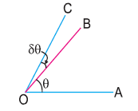
Fig. 1 Angular displacement.

Angular acceleration: it is the rate of change of angular velocity of a body with respect to the time. It is also a vector quantity.
α = $\frac{d}{dt}$ = $\frac{d}{dt}$($\frac{d}{dt}$) = $\frac{d^{2}}{{dt}^{2}}$
- Relation between linear and angular quantities of motion
Consider a body moving along a circular path from A to B, Fig.2
Let
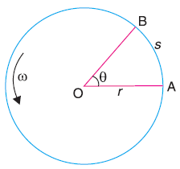
r = radius of the circular path,
θ = Angular displacement in radians,
s = Linear displacement,
v = Linear velocity,
ω = Angular velocity,
a = Linear acceleration, and
α = Angular acceleration

Fig. 2 Motion of a body along a circular path.

s = r .θ
linear velocity, v = $\frac{ds}{dt}$ = $\frac{d (r. )}{dt}$ = r × $\frac{d}{dt}$ = r. ω
linear acceleration, a = $\frac{dv}{dt}$ = $\frac{d (r. )}{dt}$ = r × $\frac{d}{dt}$ = r. α
Machine: it is a devise which receives energy in some available form and utilizes it to do some particular type of work.
Mechanism: it is a combination of rigid or resistance bodies so formed and connected that. They move upon each other with definite motion.
Link: each part of a machine, which moves relative to some other part is known as a link. A link may consist of several parts which are rigidly fastened together, so that they do not move relative to one another.
- Velocity Diagram
In order to calculate the velocity of any point in mechanism, we can use:
- Instantaneous center method
- Relative velocity method
- Relative velocity method
- Absolute velocity: it is the motion of one body relative to another body which is at rest.
- Relative velocity: it is the motion of one body relative to another body which is at motion.
- Motion of link
Consider two points A and B on a rigid link AB, as shown in Fig. 3a. Let one of the extremities (B) of the link move relative to A, in a clockwise direction. The relative of motion of B with respect to A must be perpendicular to AB.
The velocity of any point on a link with respect to another point on the same link is always perpendicular to the line joining these points.
ω = angular velocity of the link AB about A.
The relative velocity of B with respect to A (i.e. v_{BA}) is represented by the vector ab and is perpendicular to the line AB as shown in Fig. 3b.

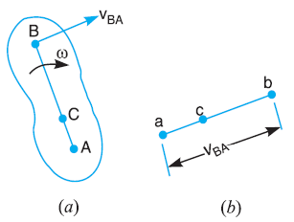
Fig. 3 Motion of a link

v_{BA} = $\overline{ab}$ = ω. AB
similarly, the velocity of any point C on AB with respect to A
v_{CA} = $\overline{ac}$ = ω. AC
$\frac{v_{CA}}{v_{BA} }$ = $\frac{\overline{ ac }}{\overline{ ab }}$ = $\frac{. AC}{ . AB}$ = $\frac{AC}{AB}$
- Velocity of point on a link
Consider two points A and B on a link as shown in Fig. 4a. let the absolute velocity of the point A i.e. v_{A} is known in magnitude and direction and the absolute velocity of the point B i.e. v_{B} is known in direction only, the velocity of B may be determined by drawing the velocity diagram as shown in Fig. 4b. The velocity diagram is drawn as the follow:
- Take some convenient point o, known as the pole.
- Through o, draw oa parallel and equal to v_{A}, to some suitable scale.
Fig. 4 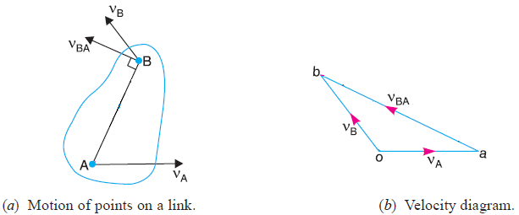
- Through a, draw a line perpendicular to AB of Fig. 4a. This line will represent the velocity of B with respect to A (v_{BA}).
- Through o, draw a line parallel to v_{B} intersecting the line v_{BA} at b.
- Measure ob, which gives the required velocity of point B (v_{B}), to the scale.
Notes:

- The absolute velocity of any point C on AB may be determined by dividing vector ab at c in the same ratio as C divides AB in Fig. 5a
$\frac{ac}{ab}$ = $\frac{AC}{AB}$
in Fig. 5b vector oc = v_{C}
and vector ac = v_{CA}
Fig. 5 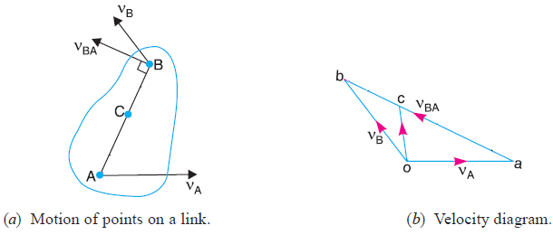
- The absolute velocity of any other point D outside AB, as shown in Fig. 6a, may also be obtained by completing the velocity triangle abd and similar to triangle ABD, as shown in Fig. 6b.
Fig. 6 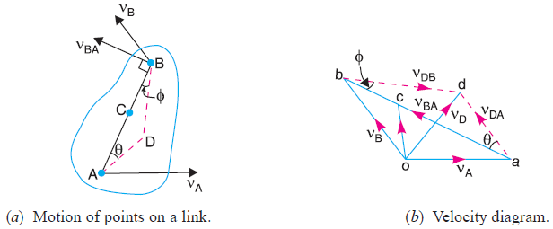
- Angular velocity of the link AB,
ω_{AB} = $\frac{v_{BA}}{AB}$ = $\frac{ab}{AB}$
- Velocity of a Block Sliding on a Rotating Link
Consider point A on the slider block, B is a point on the link and ω is the angular velocity of the link, Fig. 7. If,
v_{A}: is the velocity of block is known in magnitude and direction,
then the velocity diagram can be drawn as follow:
- From point o draw line oa which represent the velocity of A (v_{A}).
- From point o draw line ob ⊥ OA and in the direction of ω.
- From point a draw ab // OA.
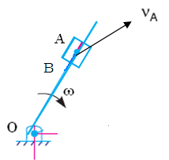 Fig. 7
Velocity diagram
o
a
b
v_{A}
v_{B}
v_{BA}
- Velocity of a Point on a Rolling Body
Consider a rolling body in Fig. 8, which rolls without slipping
ω: angular velocity,
Q: is any point on the body,
P: is the point of contact, and
r: radius of the rolling body.
It is required to find the velocities of Q and P, there are three cases:
v_{Q}
In case 1:
P
Q
v_{C}
C
ω
v_{C}
v_{PC}
ω
v_{C} = r . ω
v_{QC} = ω . QC, v_{QC} ⊥ QC
v_{Q} = v_{C} + v_{QC}
In case 2
Consider point P on a rolling body
p
q
c
v_{Q}
v_{QC}
v_{C}
v_{P} = v_{C} + v_{PC}
But v_{PC}= r . ω and v_{C} = r . ω
So v_{C} = v_{PC} therefore v_{P} = 0
Which means that point P on the rolling body gas zero absolute velocity.
In case 3
P
ω₂
ω₃
v_{P2}
v_{P3}
If two bodies roll on each other,
v_{P2} = v_{P3} (because it’s the point of contact)
But v_{P3} = v_{P2} + v_{P3P2}
v_{P3} – v_{P2} = v_{P3P2} , v_{P3P2} = 0

References
- Khurmi, ″Theory of Machines″.
- Khurmi, ″A textbook of Machine Design″.
- Shigley’s, ″Mechanical Engineering Design″, 8th edition.

