Gyroscopic Couple and Precessional Motion
When a body moves along a curved path with a uniform linear velocity, a force in the direction of centripetal acceleration (known as centripetal force) has to be applied externally over the body, so that it moves along the required curved path. This external force applied is known as active
force.
When a body, itself, is moving with uniform linear velocity along a circular path, it is subjected to the centrifugal force radially outwards. This centrifugal force is called reactive force. The action of the reactive or centrifugal force is to tilt or move the body along radially outward direction.
Centrifugal force is equal in magnitude to centripetal force but opposite in direction.

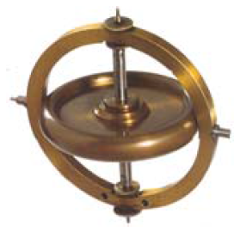
The gyroscopes are installed in ships in order to minimize the rolling and pitching effects of waves. They are also used in aeroplanes, monorail cars, gyrocompasses etc.
Gyroscopic Couple
Consider a disc spinning with an angular velocity ( ω rad/s ) about the axis of spin OX, in anticlockwise direction when seen from the front. Since the plane in which the disc is rotating is parallel to the plane YOZ, therefore it is called plane of spinning. The plane XOZ is a horizontal plane and the axis of spin rotates in a plane parallel to the horizontal plane about an axis OY. In other words, the axis of spin is said to be rotating or processing about an axis OY. In other words, the axis of spin is said to be rotating or processing about an axis OY (which is perpendicular to both the axes OX and OZ) at an angular velocity ( ω_{P} rap/s). This horizontal plane XOZ is called plane of precession and OY is the axis of precession.
Let I = Mass moment of inertia of the disc about OX, and
ω = Angular velocity of the disc.
∴ Angular momentum of the disc = I . ω
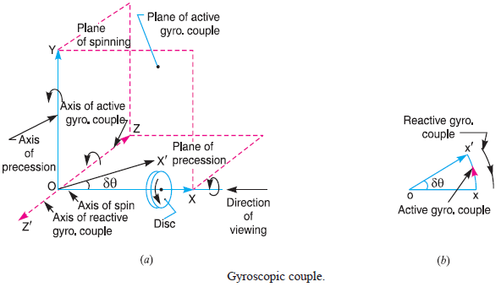
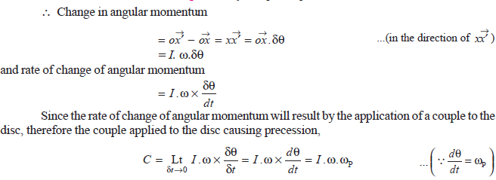
Where ω_{P} = Angular velocity of precession of the axis of spin or the speed of rotation of the axis of spin about the axis of precession OY. The units of C is N-m when I is in kg-m².
Example 1: A uniform disc of diameter 300 mm and of mass 5 kg is mounted on one end of an arm of length 600 mm. The other end of the arm is free to rotate in a universal bearing. If the disc rotates about the arm with a speed of 300 r.p.m. clockwise, looking from the front, with what speed will it precess about the vertical axis?
Solution:
We know that the mass moment of inertia of the disc, about an axis through its center of gravity and perpendicular to the plane of disc,
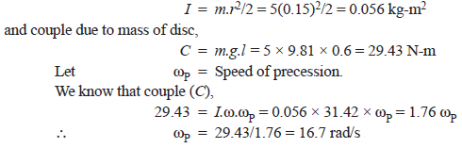
Example 2: A uniform disc of 150 mm diameter has a mass of 5 kg. It is mounted centrally in bearings which maintain its axle in a horizontal plane. The disc spins about it axle with a constant speed of 1000 r.p.m. while the axle precesses uniformly about the vertical at 60 r.p.m. The directions of rotation are as shown in Figure. If the distance between the bearings is 100 mm, find the resultant reaction at each bearing due to the mass and gyroscopic effects.
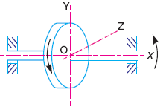
Solution:
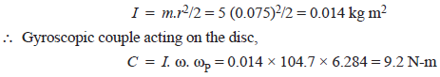
The direction of the reactive gyroscopic couple is shown in Figure. Let F be the force at each bearing due to the gyroscopic couple.
The force F will act in opposite directions at the bearings as shown in Figure. Now let R_{A} and R_{B} be the reaction at the bearing A and B respectively due to the weight of the disc. Since the disc is mounted centrally in bearings, therefore,
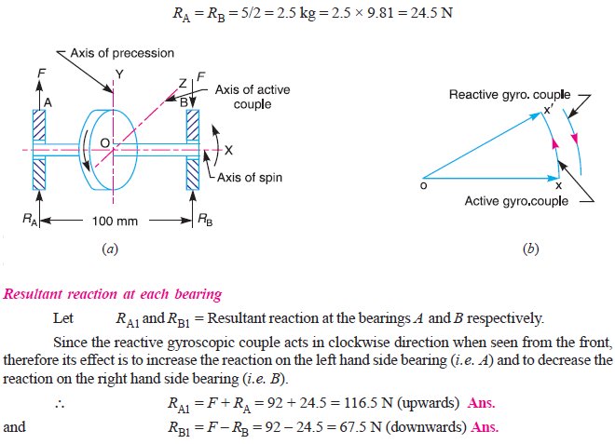

Effect of the Gyroscopic Couple on an Aeroplane
Let engine or propeller rotates in the clockwise direction when seen from the rear or tail end and the aeroplane takes a turn to the left.
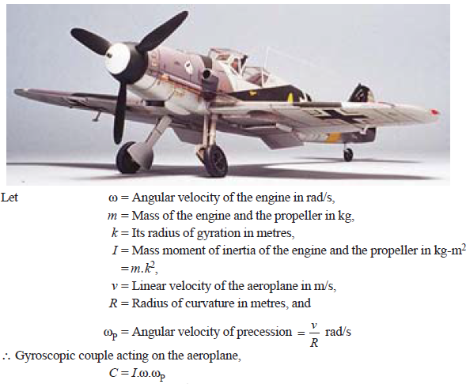
Example 3: An aeroplane makes a complete half circle of 50 metres radius, towards left, when flying at 200 km per hr. The rotary engine and the propeller of the plane has a mass of 400 kg and a radius of gyration of 0.3 m. The engine rotates at 2400 r.p.m. clockwise when viewed from the rear. Find the gyroscopic couple on the aircraft and state its effect on it.
Solution:
