- Velocities in Slider Crank Mechanism
The slider A, in Fig. 1(a) ,is attached to the connecting rod AB. v_{B} is known in magnitude and direction. The slider reciprocates along the line of stroke AO.
The velocity of the slider A (i.e. v_{A}) may be determined by follow:
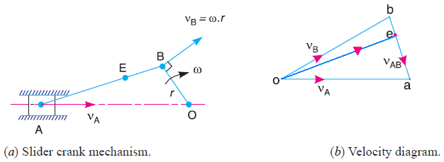
Fig. 1
- From any point o, draw vector ob parallel to the direction of v_{B} (or perpendicular to OB) such that ob = v_{B} = ω.r, to some suitable scale, as shown in Fig. 1(b).
- Draw vector ba perpendicular to AB to represent the velocity of A with respect to B i.e. v_{AB}.
- From point o, draw vector oa parallel to the path of motion of the slider A (which is along AO only). The vectors ba and oa intersect at a. Now oa represents the velocity of the slider A i.e. v_{A}, to the scale.
- To find velocity of point E $\frac{be}{BE}$ = $\frac{ba}{BA}$ and then find point e in Fig. 1(b) and then v_{E}.
ω_{AB} = $\frac{v_{BA}}{AB}$ = $\frac{ab}{AB}$ (Anticlockwise about A)
The angular velocity of the sliding member is zero.

- Rubbing Velocity at a Pin Joint
Consider two links OA and OB connected by a pin joint at O as shown in Fig. 2.
Let ω₁ = Angular velocity of the link OA or the angular velocity of the point A with respect to O.
ω₂ = Angular velocity of the link OB,
r = Radius of the pin.
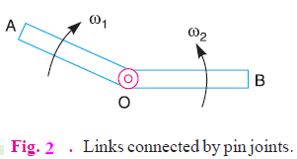

Rubbing velocity at the pin joint O
= (ω₁ – ω₂) r , if the links move in the same direction
= (ω₁ + ω₂) r , if the links move in the opposite direction
Example: 1
In a four bar chain ABCD, AD is fixed and is 150 mm long. The crank AB is 40 mm long and rotates at 120 r.p.m. clockwise, while the link CD = 80 mm oscillates about D. BC and AD are of equal length. Find the angular velocity of link CD when angle BAD = 60°.
Solution
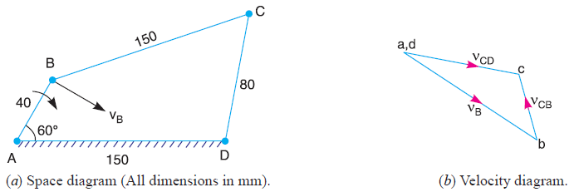
- Draw the mechanism as shown in Fig. (a) by take suitable scale, let 20mm = 1 cm in paper
- Find v_{BA} = v_{B} = ω_{BA} × AB
N_{BA} = 120 r.p.m. , ω_{BA} = 2π × 120/60 = 12.568 rad/s
v_{B} = 12.568 × 40 = 503 mm/s
- Draw the velocity diagram as shown in Fig. (b) by take suitable scale, let 503 mm/s = 4 cm in paper
- From point a,d draw line ab = 4 cm ⊥ link AB (vector ab = v_{B}), Fig. (b).
- From point b draw line bc ⊥ link BC.

- From point a,d draw line dc ⊥ link DC intersecting the line bc at c.
- Measure dc from Fig. (b)
dc = 3 cm in paper, v_{CD} = v_{C} = vector dc
v_{C} = 3 × $\frac{503}{4}$ = 378 mm/s
We know that CD = 80 mm
$∴$ Angular velocity of link CD, ω_{CD} = $\frac{v_{CD}}{DC}$ = $\frac{378}{80}$ = 4.72 rad/s
(clockwise about D) Ans.

Example: 2
The mechanism, as shown in Figure below, has the dimensions of various links as follows :
AB = DE = 150 mm ; BC = CD = 450 mm ; EF = 375 mm.
The crank AB makes an angle of 45° with the horizontal and rotates about A in the clockwise direction at a uniform speed of 120 r.p.m. The lever DC oscillates about the fixed point D, which is connected to AB by the coupler BC. The block F moves in the horizontal guides, being driven by the link EF. Determine:
- velocity of the block F,
- angular velocity of DC, and
- rubbing speed at the pin C which is 50 mm in diameter.
Solution:
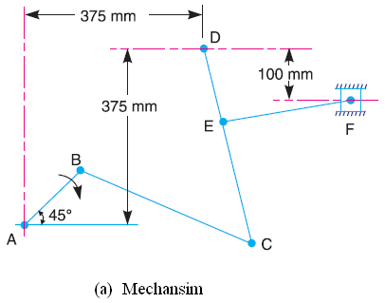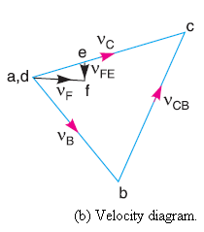

- Draw the mechanism, to some suitable scale, as shown in Fig.(a). let 100 mm = 1 cm in paper
- Find v_{BA} = v_{B} = ω_{BA} × AB
N_{BA} = 120 r.p.m. , ω_{BA} = 2π × 120/60 = 12.568 rad/s
v_{BA} = v_{B} = 12.568 × 150 = 1.885 m/s
- Draw the velocity diagram, as shown in Fig. (b), since the points A and D are fixed. Now from point a, draw vector ab ⊥ AB, to some suitable scale.
let 1.885 m/s = 3 cm in paper
vector ab = v_{B}
- From point b draw vector bc ⊥ BC to represent v_{CB}, and from point d, draw vector dc ⊥ DC to represent v_{CD} = v_{C}. The vectors bc and dc intersect at c.
- Since the point E lies on DC,
$\frac{dc}{DC}$ = $\frac{de}{DE}$
From Fig. (b) measure dc = 3.6 cm in paper
de = 3.6 × $\frac{150}{450}$ = 1.2 cm
- From point e, draw vector ef ⊥ EF to represent v_{FE}, and from point d draw vector df // to the path of motion of F, which is horizontal, to represent v_{F}. The vectors ef and df intersect at f.
From Fig. (b) measure df = 1.1 cm in paper
v_{F} = vector df = 1.1 × $\frac{1.885}{3}$ = 0.7 m/s Ans.
- v_{CD} = vector dc = 3.6 × $\frac{1.885}{3}$ = 2.26 m/s
ω_{DC} = $\frac{v_{CD}}{DC}$ = $\frac{2.26}{0.45}$ = 5 rad/s ….. (Anticlockwise about D) Ans.

- From velocity diagram, we find that v_{CB} ,
By measurement bc = 3.6 cm in paper
v_{CB} = vector bc = 3.6 × $\frac{1.885}{3}$ = 2.26 m/s
ω_{CB} = $\frac{v_{CB}}{BC}$ = $\frac{2.26}{0.45}$ = 5 rad/s ….. (Anticlockwise about B)
We know that rubbing speed at the pin C
= (ω_{CB} – ω_{CD}) r_{C} = (5 – 5) 0.025 = 0 Ans.

Home work
In a mechanism shown in Figure below, the crank OA is 100 mm long and rotates clockwise about O at 120 r.p.m. The connecting rod AB is 400mm long.

At a point C on AB, 150 mm from A, the rod CE 350 mm long is attached. This rod CE slides in a slot in a trunnion at D. The end E is connected by a link EF, 300 mm long to the horizontally moving slider F.
For the mechanism in the position shown, find 1. velocity of F, 2. velocity of sliding of CE in the trunnion, and 3. angular velocity of CE.

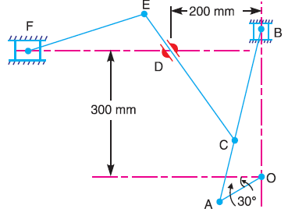

Answers
- v_{f} = 0.53 m/s.
- Velocity of sliding of CE in the trunnion = v_{D} = 1.08 m/s.
- ω_{CE} = 1.26 rad/s.

