Acceleration Diagram

In this lecture we shall discuss the acceleration of points in the mechanisms. The acceleration analysis plays a very important role in the development of machines and mechanisms.

- Acceleration Diagram for a Link
Consider two points A and B on a rigid link as shown in Fig. 1 (a). Let the point B moves with respect to A, with an angular velocity of ω rad/s and let α rad/s² be the angular acceleration of the link AB.

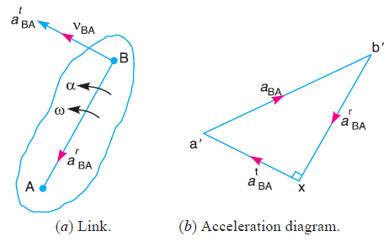
Fig.1. Acceleration for a link.

The radial component of the acceleration of B with respect to A,
a^{r}_{BA} = ω² × AB = $\frac{v_{BA}^{2}}{AB}$ (from B → A)
Radial component of acceleration a^{r}_{BA} ⊥ v_{BA}, In other words, a^{r}_{BA} // link AB.
The tangential component of the acceleration of B with respect to A,
a^{t}_{BA} = α × AB
This tangential component of acceleration // v_{BA}. In other words, a^{t}_{BA} ⊥ link AB.
a_{BA} = a^{r}_{BA} + a^{t}_{BA} (direction sum)
i. e. a_{BA} = $\sqrt{{a_{BA}^{t2}+a}_{BA}^{r2}}$

- Acceleration of a Point on a Link
Consider two points A and B on the rigid link, as shown in Fig. 2 (a). Let the acceleration of the point A i.e. a_{A} is known in magnitude and direction and the direction of path of B is given. The acceleration of the point B is determined in magnitude and direction by drawing the acceleration diagram as discussed below.

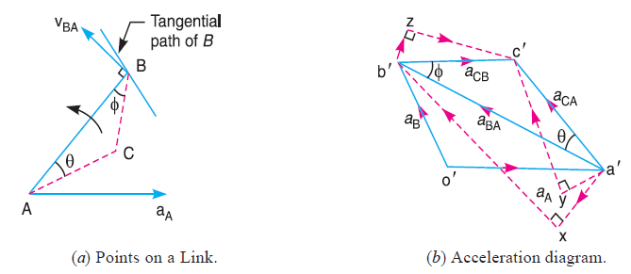
Fig. 2. Acceleration of a point on a link.
- From any point o', draw vector o'a' parallel to the direction of absolute acceleration at point A i.e. a_{A} , to some suitable scale, as shown in Fig. 2 (b).
- The acceleration of B with respect to A i.e. a_{BA} has two components a^{r}_{BA} and a^{t}_{BA}. These two components are mutually perpendicular.
- Draw vector a'x // link AB, vector a'x = a^{r}_{BA} = $\frac{v_{BA}^{2}}{AB}$
- From point x, draw vector xb'⊥ link AB or vector a'x (because a^{t}_{BA} ⊥ a^{r}_{BA}) and through o' draw a line parallel to the path of B to represent the absolute acceleration of B i.e. a_{B}. The vectors xb' and o'b' intersect at b'. Now the values of a_{B} and a^{t}_{BA} may be measured, to the scale.
- By joining the points a' and b' we may determine the total acceleration of B with respect to A i.e. a_{BA}. The vector a' b' is known as acceleration image of the link AB.
- For any other point C on the link, draw triangle a' b' c' similar to triangle ABC. vector $\acute{b}\acute{c}$ = a_{CB}, and vector a'c' = a_{CA}.
a_{CB} and a_{CA} will each have two components as follows :
- a_{CB} has two components; a^{r}_{CB} and a^{t}_{CB} as shown by triangle b'zc' in Fig. 2 (b), in which b'z // BC and zc' ⊥ b'z or BC.
- a_{CA} has two components; a^{r}_{CA} and a^{t}_{CA} as shown by triangle a'yc' in Fig. 2 (b), in which a'y // AC and yc' ⊥ a' y or AC.
- Angular acceleration of the link AB,
α_{AB} = $\frac{a_{BA}^{t}}{AB}$

- Acceleration in the Slider Crank Mechanism
A slider crank mechanism is shown in Fig. 3 (a). Let the crank OB makes an angle θ with horizontal and rotates in a clockwise direction about the fixed point O with uniform angular velocity ω_{BO} rad/s.
v_{BO} = v_{B} = ω_{BO} × OB
Radial acceleration of B (because O is a fixed point),
a^{r}_{BO} = a_{B} = ω²_{BO} × OB = $\frac{v_{BO}^{2}}{OB}$
Note: A point at the end of a link which moves with constant angular velocity has no tangential component of acceleration, a^{t}_{BO} = 0.
The acceleration diagram, as shown in Fig. 3(b), may now be drawn as discussed below:
- Draw vector o' b' // BO represent a^{r}_{BO} = a_{B}, to some suitable scale.
- From point b', draw vector b'x // BA,
vector b'x = a^{r}_{BA} = $\frac{v_{BA}^{2}}{AB}$
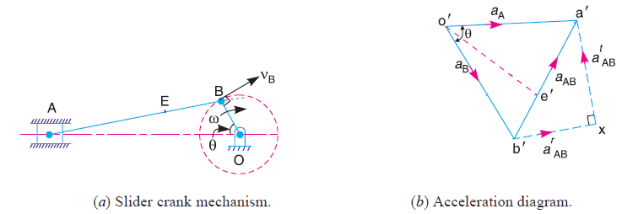
Fig. 3. Acceleration in the slider crank mechanism.

- From point x, draw vector xa' ⊥ b'x (or AB). The vector xa' represents a^{t}_{AB} .
- From o', draw o'a' // AO, intersecting the vector xa' at a'.
Now the acceleration of the piston or the slider A (a_{A}) and a^{t}_{AB} may be measured to the scale.
- a_{AB} = vector b'a' = b' x + x a' (vectors sum)
- The acceleration of any other point on AB such as E can be obtained by
$\frac{{a^{}b}^{}}{AB}$ = $\frac{{a^{}e}^{}}{AE}$
- Angular acceleration of the connecting rod AB,
α_{AB} = $\frac{a_{AB}^{t}}{AB}$ (Clockwise about B)
Example: 1
The crank of a slider crank mechanism rotates clockwise at a constant speed of 300 r.p.m. The crank is 150 mm and the connecting rod is 600 mm long. Determine :
- linear velocity and acceleration of the midpoint of the connecting rod, and
- angular velocity and angular acceleration of the connecting rod, at a crank angle of 45° from inner dead centre position.

Solution:
- Draw the mechanism, to some suitable scale, as shown in Fig.(a). let 100 mm = 1 cm in paper
- Find v_{BO} = v_{B} = ω_{BO} × OB
N_{OB} = 300 r.p.m. , ω_{BA} = 2π × 300/60 = 31.42 rad/s
v_{BO} = v_{B} = 31.42 × 150 = 4.713 m/s

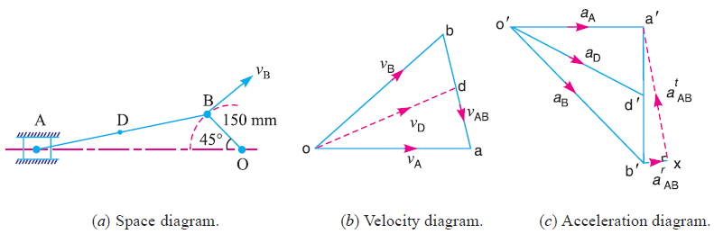
- Draw the velocity diagram, as shown in Fig. (b), since the point O is fixed. Now from point o, draw vector ob ⊥ OB, to some suitable scale.
let 4.713 m/s = 5 cm in paper
vector ob = v_{B}
- From point b draw vector ba ⊥ BA to represent v_{AB}, and from point o, draw vector oa parallel to the motion of A (which is along AO) to represent v_{A}. The vectors ba and oa intersect at a.
By measurement, we find that
v_{AB} = vector ab = 3.6 × $\frac{4.713}{5}$ = 3.4 m/s
Angular velocity of the connecting rod = ω_{AB} = $\frac{v_{AB}}{AB}$ = $\frac{3.4}{0.6}$ = 5.67 rad/s.
(Anticlockwise about B) Ans.

v_{A} = vector oa = 4.2 × $\frac{4.713}{5}$ = 4 m/s
- Since the point D lies on AB,
$\frac{ba}{BA}$ = $\frac{bd}{BD}$
Note: Point D is the midpoint of AB, therefore d is also midpoint of vector ba.
By measurement, we find that
v_{D} = vector od = 4.3 × $\frac{4.713}{5}$ = 4.1 m/s Ans.

Draw the acceleration diagram, as shown in Fig. (c)
- a^{r}_{BO} = a_{B} = $\frac{v_{BO}^{2}}{OB}$ = $\frac{4.713 }{0.15}$ = 148.1 m/s²
a^{r}_{AB} = $\frac{v_{AB}^{2}}{OB}$ = $\frac{3.4 }{0.6}$ = 19.3 m/s²
Scale for acceleration diagram: let 148.1 m/s² = 5 cm in paper
- Draw vector o'b' // BO to represent a^{r}_{BO} or a_{B},
vector o'b' = a^{r}_{BO} = a_{B} = 5 cm (from B → O)

Note: Since the crank OB rotates at a constant speed, therefore a^{t}_{BO} = 0
- The acceleration of A with respect to B (a_{AB}) has two components:
a_{AB} = a^{r}_{AB} + a^{t}_{AB}
from point b', draw vector b' x // AB to represent a^{r}_{AB} = 19.3 m/s = 0.7 cm in paper (from A → B), and from point x draw vector xa' ⊥ vector b'x whose magnitude is yet unknown.
- Now from o', draw vector o'a' parallel to the path of motion of A (which is along AO) to represent a_{A} . The vectors xa' and o'a' intersect at a'. Join a' b'.
- Point D is the midpoint of AB, therefore d' is also midpoint of vector b'a',
$\frac{\acute{b}\acute{a}}{BA}$ = $\frac{\acute{b}\acute{d}}{BD}$
Vector $\acute{o}\acute{d}$ = 3.95 cm in paper
a_{D} = vector $\acute{o}\acute{d}$ = 3.95 × $\frac{148.1}{5}$ = 117 m/s² Ans.
$\acute{b}\acute{a}$ = 3.45 cm in paper
a^{t}_{AB} = vector $\acute{b}\acute{a}$ = 3.45 × $\frac{148.1}{5}$ = 103 m/s²
α_{AB} = $\frac{a_{AB}^{t}}{BA}$ = $\frac{103}{0.6}$ = 171.67 m/s² (Clockwise about B) Ans.

Example :2
In the mechanism, as shown in Figure below, the crank OA rotates at 20 r.p.m. anticlockwise and gives motion to the sliding blocks B and D. The dimensions of the various links are OA = 300 mm; AB = 1200 mm; BC = 450 mm and CD = 450 mm. For the given configuration, determine :
- velocities of sliding at B and D,
- Angular velocity of CD,
- linear acceleration of D, and
- angular acceleration of CD.
