Balancing of Masses
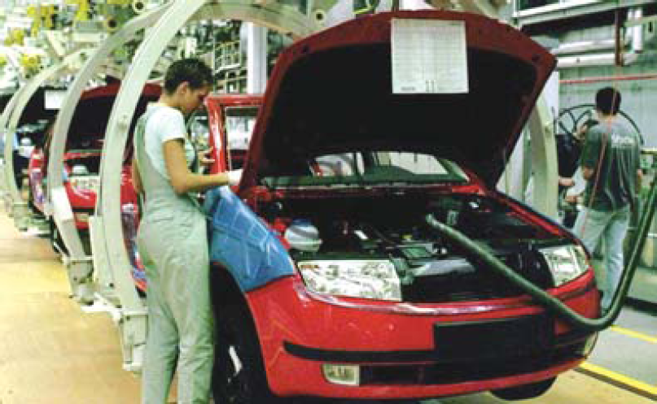
A car assembly line.
In this chapter we shall discuss the balancing of unbalanced forces caused by rotating masses, in order to minimize the loads on bearings and stresses in the various members, which causes dangerous vibrations when a machine is running.
The following cases are important from the subject point of view:
- Balancing of a single rotating mass by a single mass rotating in the same plane.
- Balancing of a single rotating mass by two masses rotating in different planes.
- Balancing of different masses rotating in the same plane.
- Balancing of different masses rotating in different planes.

- Balancing of a Single Rotating Mass By a Single Mass Rotating in the Same Plane

Consider a disturbing mass m₁ attached to a shaft rotating at ω rad/s as shown in Fig .1. Let r₁ be the radius of rotation of the mass m₁. We know that the centrifugal force exerted by the mass m₁ on the shaft,
F_{Cl} = m₁. ω². r₁ …………….(1)

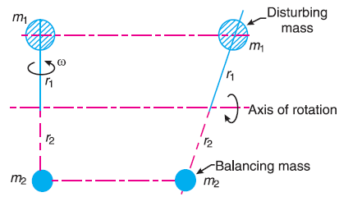
Fig. 1. Balancing of a single rotating mass by a single mass rotating in the same plane.

This centrifugal force produces bending moment on the shaft. In order to counteract the effect of this force, a balancing mass (m₂) may be attached in the same plane of rotation as that of disturbing mass (m₁) such that the centrifugal forces due to the two masses are equal and opposite.
Let r₂ = Radius of rotation of the balancing mass m₂, centrifugal force due to mass m₂,
F_{C2} = m₂. ω². r₂ …………….(2)
Equating equations (1) and (2),
m₁. ω². r₁ = m₂. ω². r₂ or m₁. r₁ = m₂. r₂

- Balancing of a Single Rotating Mass By Two Masses Rotating in
Different Planes
In order to put the system in complete balance, two balancing masses are placed in two different planes, parallel to the plane of rotation of the disturbing mass, There are two possibilities may arise while attaching the two balancing masses:

- When the plane of the disturbing mass lies in between the planes of the two balancing masses

Consider a disturbing mass m balanced by two rotating masses m₁ and m₂ as shown in Fig. 2. Let r, r₁ and r₂ be the radii of rotation of the masses m, m₁ and m₂ respectively.
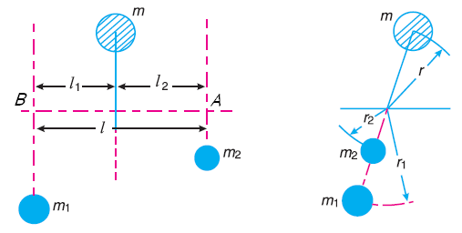
Fig .2. Balancing of a single rotating mass by two rotating masses in different planes when the
plane of single rotating mass lies in between the planes of two balancing masses.

The net force acting on the shaft must be equal to zero
F_{C} = F_{Cl} + F_{C2}
F_{C} : Centrifugal force exerted by the mass m
F_{C1} : Centrifugal force exerted by the mass m₁
F_{C2} : Centrifugal force exerted by the mass m₂
m. ω². r = m₁. ω². r₁ + m₂. ω². r₂
m. r = m₁. r₁ + m₂. r₂
Now in order to find the magnitude of balancing force at the bearing B of a shaft, take moments about A. Therefore
F_{C1} × l = F_{C} × l₂ or m₁. ω². r₁ × l = m. ω². r × l₂
∴ m₁. r₁ × l = m. r × l₂
Similarly, in order to find the balancing force at the bearing A of a shaft, take moments about B. Therefore
F_{C2} × l = F_{C} × l₁ or m₂. ω². r₂ × l = m. ω². r × l₁
∴ m₂. r₂ × l = m. r × l₁

- When the plane of the disturbing mass lies on one end of the planes of the balancing masses

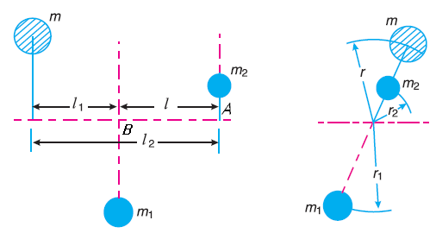

Fig .3. Balancing of a single rotating mass by two rotating masses in different planes, when the
plane of single rotating mass lies at one end of the planes of balancing masses.

This case shown in Fig .3. As discussed above, the following conditions must be satisfied in order to balance the system, i.e.
F_{C} + F_{C2} = F_{Cl} or m. ω². r + m₂. ω². r₂ = m₁. ω². r₁
∴ m. r + m₂. r₂ = m₁. r₁
Now in order to find the magnitude of balancing force at the bearing B of a shaft, take moments about A. Therefore
F_{C1} × l = F_{C} × l₂ or m₁. ω². r₁ × l = m. ω². r × l₂
∴ m₁. r₁ × l = m. r × l₂
Similarly, to find the balancing force at the bearing A of a shaft, take moments about B. Therefore
F_{C2} × l = F_{C} × l₁ or m₂. ω². r₂ × l = m. ω². r × l₁
∴ m₂. r₂ × l = m. r × l₁
- Balancing of Several Masses Rotating in the Same Plane
Consider any number of masses (say four) of magnitude m₁, m₂, m₃ and m₄ at distances of r₁, r₂, r₃ and r₄ from the axis of the rotating shaft. Let θ₁, θ₂,θ₃ and θ₄ be the angles of these masses with the horizontal line OX, as shown in Fig. 4 (a). Let these masses rotate about an axis through O and perpendicular to the plane of paper, with a constant angular velocity of ω rad/s.
The magnitude and position of the balancing mass may be found out analytically or graphically as discussed below:
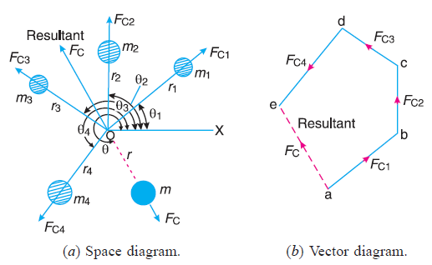
Fig .4. Balancing of several masses rotating in the same plane.

- Analytical method
The magnitude and direction of the balancing mass may be obtained, analytically, as discussed below :
Resolve the centrifugal forces horizontally and vertically and find their sums, i.e.
ΣH = m₁ . r₁ cosθ₁ + m₂ . r₂ cosθ₂ + . . . . . .
ΣV = m₁ . r₁ sinθ₁ + m₂ . r₂ sinθ₂ + . . . . . .
Magnitude of the resultant centrifugal force,
F_{C} = $\sqrt{{(ΣH)}^{2}+ ({ΣV)}^{2}}$
If θ is the angle, which the resultant force makes with the horizontal, then
tan θ = $\frac{ΣV}{H}$
The balancing force is then equal to the resultant force, but in opposite direction. Now find out the magnitude of the balancing mass,
F_{C} = m. r
where m = Balancing mass, and
r = Its radius of rotation.
- Graphical method
The magnitude and position of the balancing mass may also be obtained graphically using Table: 1 and then draw:
- Find the centrifugal force (or product of the mass and radius of rotation) exerted by each mass on the rotating shaft.
- Draw the vector diagram with the obtained centrifugal forces to some suitable scale.
- The closing side of polygon ae represents the resultant force in magnitude and direction, as shown in Fig. 4 (b).
- The balancing force is, then, equal to the resultant force, but in opposite direction.
- Find the magnitude of the balancing mass (m) at a given radius of rotation (r),
m.r = Resultant of m₁.r₁, m₂.r₂, m₃.r₃ and m₄.r₄
Table: 1
No. of masses | Mass (m) | Radius (r) | Angle(θ) | Centrifugal force ÷ ω² (m.r)
1 | m₁ | r₁ | θ₁ | m₁ r₁
2 | m₂ | r₂ | θ₂ | m₂.r₂
3 | m₃ | r₃ | θ₃ | m₃.r₃
4 | m₄ | r₄ | θ₄ | m₄.r₄

- Balancing of Several Masses Rotating in Different Planes
Let us consider four masses m₁, m₂, m₃ and m₄ revolving in planes 1, 2, 3 and 4 respectively as shown in Fig. 5(a). The relative angular positions of these masses
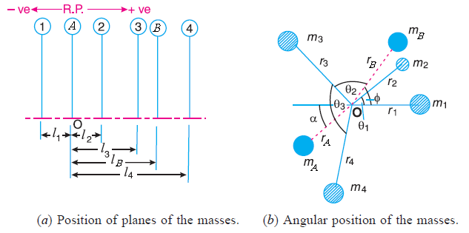
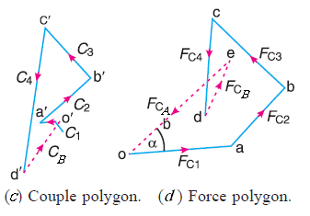
Fig. 5. Balancing of several masses rotating in different planes.

are shown in Fig. 5(b). The magnitude of the balancing masses m_{A} and m_{B} in planes A and B may be obtained as discussed below:
- Take one of the planes, say A as the reference plane (R.P.).
- Tabulate the data as shown in Table: 2.
- The couples about the reference plane must balance, i.e. the resultant couple must be zero.
$\sum_{i=1}^{n}{m_{i}{ r}_{i}{ l}_{i}\cos{θ_{i}}}$ + m_{B} r_{B} l_{B}$\cos{θ_{B}}$ = 0
$\sum_{i=1}^{n}{m_{i}{ r}_{i}{ l}_{i}\sin{θ_{i}}}$ + m_{B} r_{B} l_{B}$\sin{θ_{B}}$ = 0
- The forces in the reference plane must balance, i.e. the resultant force must be zero.
$\sum_{i=1}^{n}{m_{i}{ r}_{i}\cos{θ_{i}}}$ + m_{A} r_{A} $\cos{θ_{A}}$ = 0
$\sum_{i=1}^{n}{m_{i}{ r}_{i}\sin{θ_{i}}}$ + m_{A} r_{A} ${\sin{θ_{A}}}$ = 0
Where n: number of masses.
Table: 2
plane | Mass (m) | Radius (r) | Angle(θ) | Centrifugal force ÷ ω² (m.r) |  | Distance from  Plane A (l) | Couple ÷ ω² (m.r.l)
1 | m₁ | r₁ | θ₁ | m₁.r₁ |  | –l₁ | –m₁.r₁.l₁
A(R.P.) | m_{A} | r_{A} | θ_{A} | m_{A}.r_{A} |  | 0 | 0
2 | m₂ | r₂ | θ₂ | m₂.r₂ |  | l₂ | m₂.r₂.l₂
3 | m₃ | r₃ | θ₃ | m₃.r₃ |  | l₃ | m₃.r₃.l₃
B | m_{B} | r_{B} | θ_{B} | m_{B}.r_{B} |  | l_{B} | m_{B}.r_{B}.l_{B}
4 | m₄ | r₄ | θ₄ | m₄.r₄ |  | l₄ | m₄.r₄.l₄

Graphical Representation
- Draw moment polygon (assuming that the moment direction is toward the centrifugal force) as shown in Fig .5(c).
- Draw force polygon as shown in Fig .5(d).
Example: 1
Four masses m₁, m₂, m₃ and m₄ are 200 kg, 300 kg, 240 kg and 260 kg respectively. The corresponding radii of rotation are 0.2 m, 0.15 m, 0.25 m and 0.3 m respectively and the angles between successive masses are 45°, 75° and 135°. Find the position and magnitude of the balance mass required, if its radius of rotation is 0.2 m.
Solution:
Let m = Balancing mass, and
θ = The angle which the balancing mass makes with m₁.
- Analytical method
ΣH =$\sum_{i=1}^{n}{m_{i}{ r}_{i}\cos{θ_{i}}}$
ΣH = 40 cos0 + 45 cos45 + 60 cos120 + 78 cos255 = 21.63 kg.m

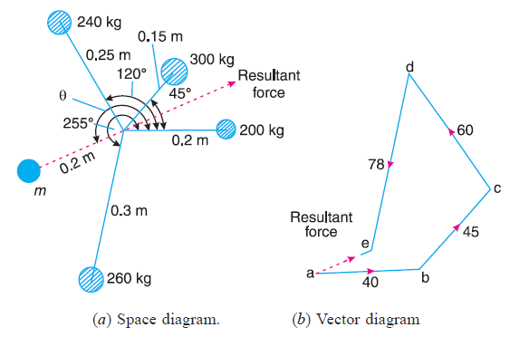
No. of masses | Mass (kg) | Radius (m) | Angle(deg.) | Centrifugal force ÷ ω² (kg.m)
1 | 200 | 0.2 | 0 | 40
2 | 300 | 0.15 | 45 | 45
3 | 240 | 0.25 | 120 | 60
4 | 260 | 0.3 | 255 | 78
5 | m | 0.2 | θ | m.r
ΣV =$\sum_{i=1}^{n}{m_{i}{ r}_{i}\sin{θ_{i}}}$
ΣV = 40 sin0 + 45 sin45 + 60 sin120 + 78 sin255 = 8.43 kg.m
F_{C} = $\sqrt{{(2163.2 )}^{2}+ ({843.9)}^{2}}$ = 23.21 kg.m
F_{C} = m.r, 23.21 = 0.2 × m ∴ m = 116 kg Ans.
tan $\acute{θ}$ = $\frac{ΣV}{H}$ = $\frac{8.43}{21.63 }$ ∴ = 21.3°
Since $\acute{θ}$ is the angle of the resultant R from the horizontal mass of 200 kg, therefore the angle of the balancing mass from the horizontal mass of 200 kg,
θ = 180° + 21.48° = 201.48° Ans.
- Graphical method
Scale: let 10 kg.m = 1cm in paper.
Draw force polygon as shown in Fig .(b).

Example: 2
A shaft carries four masses A, B, C and D of magnitude 200 kg, 300 kg, 400 kg and 200 kg respectively and revolving at radii 80 mm, 70 mm, 60 mm and 80 mm in planes measured from A at 300 mm, 400 mm and 700 mm. The angles between the cranks measured anticlockwise are A to B 45°, B to C 70° and C to D 120°. The balancing masses are to be placed in planes X and Y. The distance between the planes A and X is 100 mm, between X and Y is 400 mm and between Y and D is 200 mm. If the balancing masses revolve at a radius of 100 mm, find their magnitudes and angular positions.

Solution
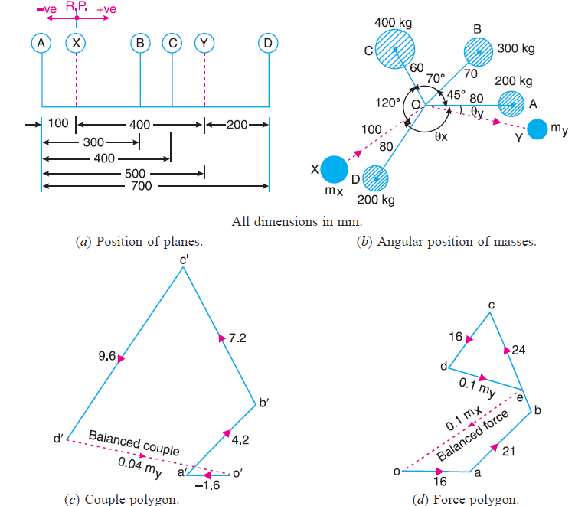

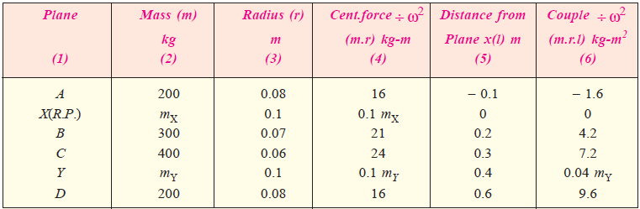

Home work

A shaft has three eccentrics, each 75 mm diameter and 25 mm thick, machined in one piece with the shaft. The central planes of the eccentric are 60 mm apart. The distance of the centres from the axis of rotation are 12 mm, 18 mm and 12 mm and their angular positions are 120° apart. The density of metal is 7000 kg/m³. Find the amount of out-of-balance force and couple at 600 r.p.m. If the shaft is balanced by adding two masses at a radius 75 mm and at distances of 100 mm from the central plane of the middle eccentric, find the amount of the masses and their angular positions.

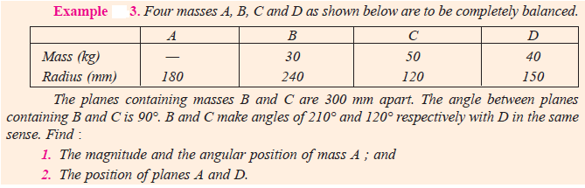
Solution:
