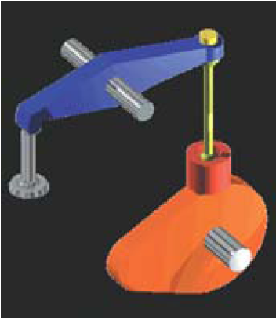

Cams

A cam is a rotating machine element which gives reciprocating or oscillating motion to another element known as follower. The cam and follower is one of the simplest as well as one of the most important mechanisms found in modern machinery today. The cams are widely used for operating the inlet and exhaust valves of internal combustion engines.

- Classification of Cams
- Radial or disc cam, is shown in Fig. 1 (a) to (f).
- Cylindrical cam, is shown in Fig .2.

- Classification of Followers
- According to the surface in contact. The followers, according to the surface in contact, are as follows :
- Knife edge follower, is shown in Fig .1 (a).
- Roller follower, is shown in Fig .1 (b).
- Flat faced or mushroom follower, is shown in Fig .1 (c) and (f ).
- Spherical faced follower, is shown in Fig .1 (d).
- According to the motion of the follower. The followers, according to its motion, are of the following two
- Reciprocating or translating follower, is shown in Fig .1 (a) to (d).
- Oscillating or rotating follower, is shown in Fig .1 (e).
- According to the path of motion of the follower. The followers, according to its path of motion, are of the following two types:
- Radial follower, is shown in Fig .1 (a) to (e).
- Off-set follower, is shown in Fig .1 ( f ).

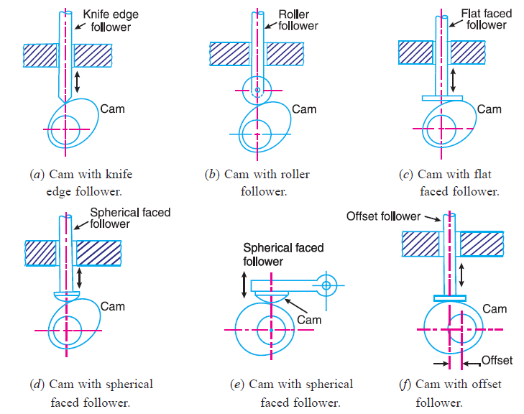
Fig .1. Classification of followers.

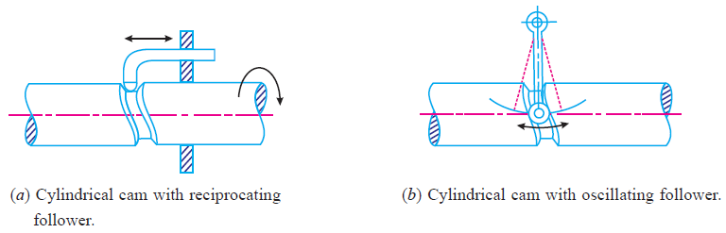
Fig .2. Cylindrical cam.

- Motion of the Follower
The follower, during its travel, may have one of the following motions.
- Uniform velocity,
- Simple harmonic motion, and
- Uniform acceleration and retardation.
We shall now discuss the displacement, velocity and acceleration diagrams for the cam when the follower moves with the above mentioned motions.

- Uniform Velocity Motion
The displacement, velocity and acceleration diagrams when a knife-edged follower moves with uniform velocity are shown in Fig. 3(a), (b) and (c) respectively. Since the follower moves with uniform velocity during its rise and return stroke, therefore the slope of the displacement curves must be constant. In other words, AB₁ and C₁D must be straight lines. The periods during which the follower remains at rest are known as dwell periods as shown by lines B₁C₁ and DE. The acceleration or retardation of the follower at the beginning and at the end of each stroke is infinite. This is due to the fact that the follower is required to start from rest and has to gain a velocity within no time.
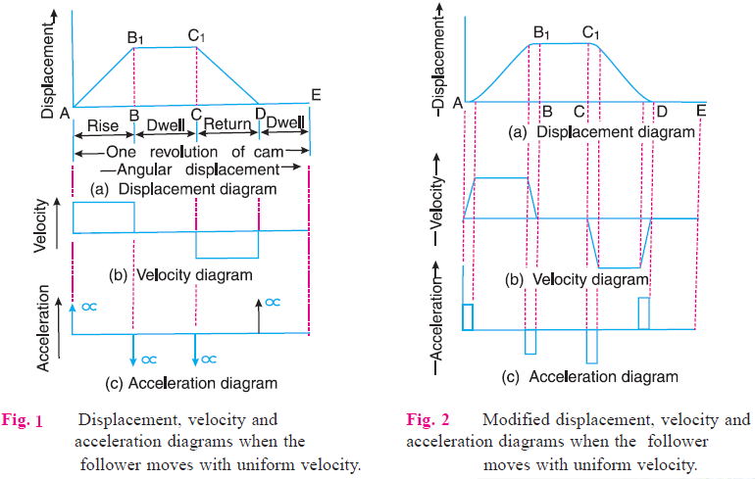
3
4
In order to have the acceleration and retardation within the finite limits, it is necessary to modify the conditions which govern the motion of the follower. This may be done by rounding off the sharp corners of the displacement diagram at the beginning and at the end of each stroke, as shown in Fig. 4(a). By doing so, the velocity of the follower increases gradually to its maximum value at the beginning of each stroke and decreases gradually to zero at the end of each stroke as shown in Fig. 4(b).

- Simple Harmonic Motion
The displacement, velocity and acceleration diagrams when the follower moves with simple harmonic motion are shown in Fig. 5(a), (b) and (c) respectively. The displacement diagram is drawn as follows :
- Draw a semi-circle on the follower stroke as diameter.
- Divide the semi-circle into any number of even equal parts (say eight).
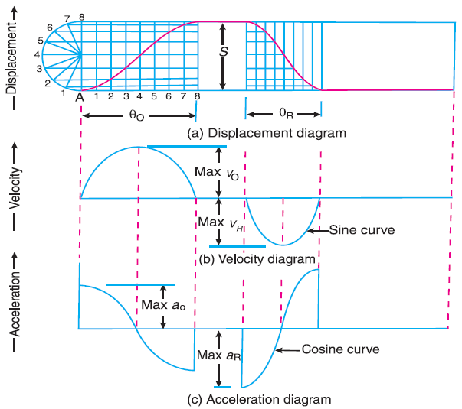
Fig. 5. Displacement, velocity and acceleration diagrams when the follower moves with simple harmonic motion.
- Divide the angular displacements of the cam during out stroke and return stroke into the same number of equal parts.
- The displacement diagram is obtained by projecting the points as shown in Fig. 5(a).
Since the follower moves with a simple harmonic motion, therefore velocity diagram consists of a sine curve and the acceleration diagram is a cosine curve.
Let S = Stroke of the follower,
θ_{O} and θ_{R} = Angular displacement of the cam during out stroke and return
stroke of the follower respectively, in radians, and
ω = Angular velocity of the cam in rad/s.
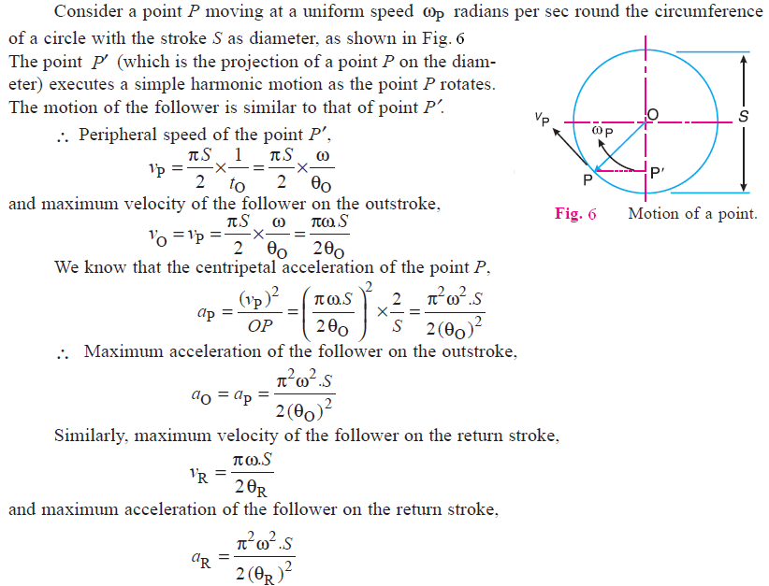
……(t_{O} = θ_{O} /ω)

- Uniform Acceleration and Retardation
The displacement, velocity and acceleration diagrams when the follower moves with uniform acceleration and retardation are shown in Fig. 7(a), (b) and (c) respectively. We see that the displacement diagram consists of a parabolic curve and may be drawn as discussed below :
- Divide the angular displacement of the cam during outstroke (θ_{O}) into any even number of equal parts (say eight) and draw vertical lines through these points.
- Divide the stroke of the follower (S) into the same number of equal even parts.
- Join Aa to intersect the vertical line through point 1 at B. Similarly, obtain the other points C, D etc., Fig. 7(a). Now join these points to obtain the parabolic curve for the out stroke of the follower.
- In the similar way as discussed above, the displacement diagram for the follower during return stroke may be drawn.
Since the acceleration and retardation are uniform, therefore the velocity varies directly with the time.
We know that time required for the follower during outstroke,
t_{O} = θ_{O} / ω
and time required for the follower during return stroke,
t_{R} = θ_{R} / ω

Mean velocity of the follower during outstroke
= S / t_{O}

and mean velocity of the follower during return stroke
= S / t_{R}

Maximum velocity of the follower during outstroke,
v_{O} = $\frac{2 S}{t_{O}}$ = $\frac{2 .S}{θ_{O}}$
Similarly, maximum velocity of the follower during return stroke,
v_{R} = $\frac{2 .S}{θ_{R}}$
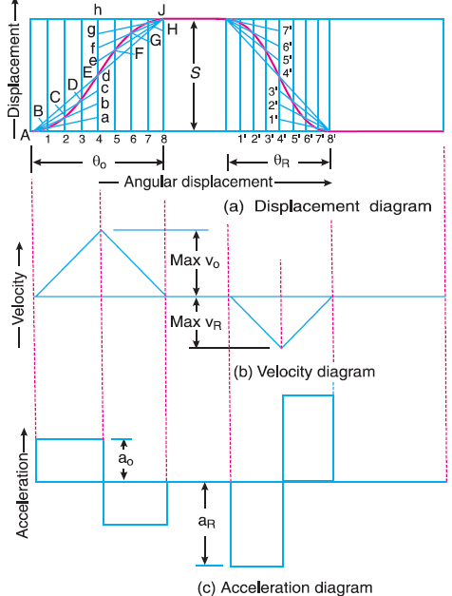
Fig. 7. Displacement, velocity and acceleration diagrams when the follower moves
with uniform acceleration and retardation.

Maximum acceleration of the follower during outstroke,
a_{O} = $\frac{v_{O}}{{t_{O}}/2}$ = $\frac{2 × 2 .S}{{t_{O} . θ}_{O}}$ = $\frac{4 {}^{2 }. S}{{(θ_{O})}^{2}}$ ……(t_{O} = θ_{O} /ω)
Similarly, maximum acceleration of the follower during return stroke,
a_{R} = $\frac{4 {}^{2 }. S}{ {(θ_{R})}^{2}}$

Construction of Cam Profile
In order to draw the cam profile for a radial cam, first of all the displacement diagram for the given motion of the follower is drawn. Then the principle of kinematic inversion is used, i.e. the cam is imagined to be stationary and the follower is allowed to rotate in the opposite direction to the cam rotation.

Example: 1
A cam is to give the following motion to a knife-edged follower:
- Outstroke during 60° of cam rotation;
- Dwell for the next 30° of cam rotation ;
- Return stroke during next 60° of cam rotation, and
- Dwell for the remaining 210° of cam rotation.
The stroke of the follower is 40 mm and the minimum radius of the cam is 50mm. The follower moves with uniform velocity during both the outstroke and return strokes. Draw the profile of the cam when
- the axis of the follower passes through the axis of the cam shaft, and
- the axis of the follower is offset by 20mm from the axis of the cam shaft.
Solution:
First of all, the displacement diagram, as shown in Fig. 8, is drawn as discussed in the following steps :
- Draw a horizontal line AX = 360° to some suitable scale.
AS = θ_{O} = 60°
ST = θ_{D} = 30°
TP = θ_{R} = 60°
PX = θ_{D} = 210°
- Draw vertical line AY equal to the stroke of the follower (i.e. 40 mm) and complete the rectangle as shown in Fig. 8.
- Divide the angular displacement during outstroke and return stroke into any equal number of even parts (say six) and draw vertical lines through each point.
- Since the follower moves with uniform velocity during outstroke and return stroke, therefore the displacement diagram consists of straight lines. Join AG and HP.
- The complete displacement diagram is shown by AGHPX.

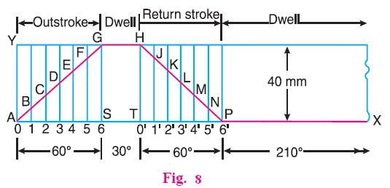

(a)
The profile of the cam when the axis of the follower passes through the axis of the cam shaft, as shown in Fig. 9, is drawn as discussed in the following steps:
- Draw a base circle with radius equal to the minimum radius of the cam (i.e. 50 mm).
- From OA, mark angle AOS = θ_{O} = 60°
SOT = θ_{D} = 30°
TOP = θ_{R} = 60°
- Divide the angular displacements during outstroke and return stroke (i.e. angle AOS and angle TOP) into the same number of equal even parts as in displacement diagram.
- Now set off 1B, 2C, 3D ... etc. and 0′ H,1′ J ... etc. from the displacement diagram.
- Join the points A, B, C,... M, N, P with a smooth curve. The curve AGHPA is the complete profile of the cam.

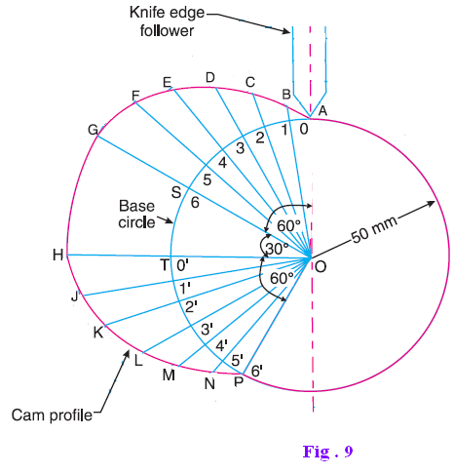
(b)
The profile of the cam when the axis of the follower is offset by 20 mm from the axis of the cam shaft, as shown in Fig. 10 , is drawn as discussed in the following steps :
- Draw a base circle with radius equal to the minimum radius of the cam (i.e. 50 mm) with O as centre.
- Draw the axis of the follower at a distance of 20 mm from the axis of the cam, which intersects the base circle at A.
- Join AO and draw an offset circle of radius 20 mm with centre O.
- From OA, mark angle AOS = θ_{O} = 60°
SOT = θ_{D} = 30°
TOP = θ_{R} = 60°
- Divide the angular displacement during outstroke and return stroke (i.e. angle AOS and angle TOP) into the same number of equal even parts as in displacement diagram.
- Now from the points 1, 2, 3 ... etc. and 0′,1′, 2′,3′ ... etc. on the base circle, draw tangents to the offset circle.
- Now set off 1B, 2C, 3D ... etc. and 0′ H,1′ J ... etc. from the displacement diagram.
- Join the points A, B, C ...M, N, P with a smooth curve. The curve AGHPA is the complete profile of the cam.

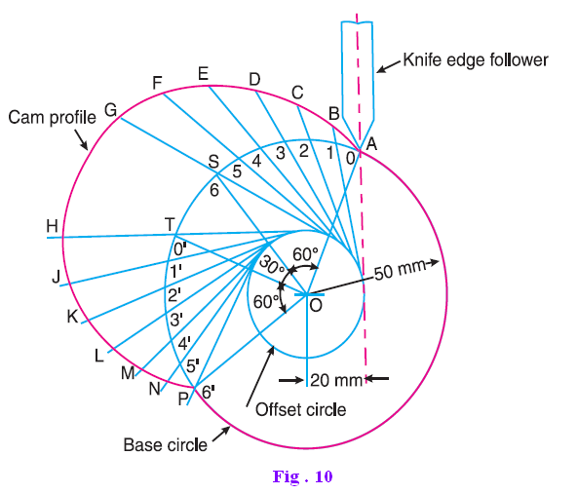
Example: 2
A cam, with a minimum radius of 25 mm, rotating clockwise at a uniform speed is to be designed to give a roller follower, at the end of a valve rod, motion described below :
- To raise the valve through 50 mm during 120° rotation of the cam ;
- To keep the valve fully raised through next 30°;
- To lower the valve during next 60°; and
- To keep the valve closed during rest of the revolution i.e. 150° ;
The diameter of the roller is 20 mm and the diameter of the cam shaft is 25 mm.
Draw the profile of the cam when
- the line of stroke of the valve rod passes through the axis of the cam shaft,
- the line of the stroke is offset 15 mm from the axis of the cam shaft.
The displacement of the valve, while being raised and lowered, is to take place with simple harmonic motion. Determine the maximum acceleration of the valve rod when the cam shaft rotates at 100 r.p.m.
Draw the displacement, the velocity and the acceleration diagrams for one complete revolution of the cam.

Solution:
First of all, the displacement diagram, as shown in Fig. 11(a), is drawn as discussed in the following steps :
- Draw horizontal line AX = 360° to some suitable scale. On this line, mark
AS = θ_{O} = 120°
ST = θ_{D} = 30°
TP = θ_{R} = 60°
PX = θ_{D} = 150°
- Draw vertical line AY = 50 mm to represent the cam lift or stroke of the follower and complete the rectangle.
- Divide the angular displacement during out stroke and return stroke into any equal number of even parts (say six) and draw vertical lines through each point.
- Since the follower moves with simple harmonic motion, therefore draw a semicircle with AY as diameter and divide into six equal parts.
- From points a, b, c ... etc. draw horizontal lines intersecting the vertical lines drawn through 1, 2, 3 ... etc. and 0′ ,1′ , 2′ ...etc. at B, C, D ... M, N, P.
- Join the points A, B, C ... etc. with a smooth curve.

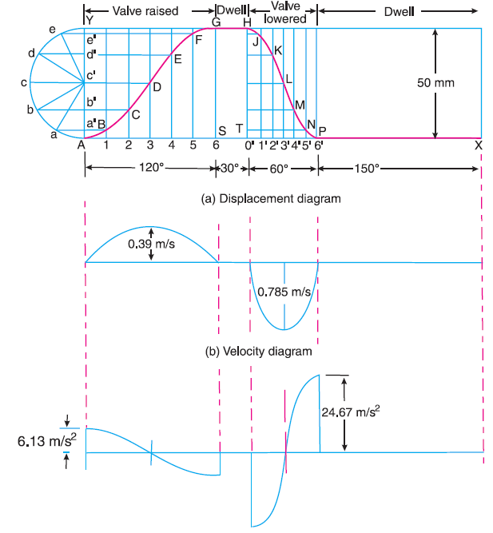
Fig. 11 (c) Acceleration diagram
(a)
The profile of the cam when the line of stroke of the valve rod passes through the axis of the cam shaft, as shown in Fig. 13, is drawn as discussed in the following steps :
- Draw a base circle with centre O and radius equal to the minimum radius of the cam ( i.e. 25 mm ).
- Draw a prime circle with centre O and radius,
OA = Min. radius of cam + $\frac{1}{2}$Dia. of roller = 25 + $\frac{1}{2}$× 20 = 35 mm
- From OA, mark angle AOS = θ_{O} = 120°
SOT = θ_{D} = 30°
TOP = θ_{R} = 60°

- Divide the angular displacements of the cam during raising and lowering of the valve (i.e. angle AOS and TOP ) into the same number of equal even parts as in displacement diagram.
- Join the points 1, 2, 3, etc. with the centre O and produce the lines beyond prime circle.
- Set off 1B, 2C, 3D etc. equal to the displacements from displacement diagram.
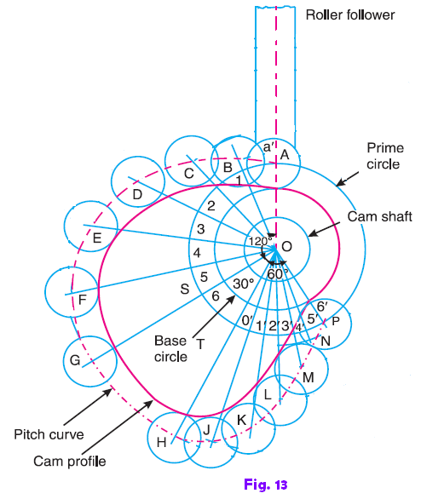
- Join the points A, B, C ... N, P, A. The curve drawn through these points is known as pitch curve.
- From the points A, B, C ... N, P, draw circles of radius equal to the radius of the roller.
- Join the bottoms of the circles with a smooth curve.

(b)
Profile of the cam when the line of stroke is offset 15 mm from the axis of the cam shaft, as shown in Fig. 14, may be drawn as discussed in the following steps:
- Draw a base circle with centre O and radius equal to 25 mm.
- Draw a prime circle with centre O and radius OA = 35 mm.
- Draw an off-set circle with centre O and radius equal to 15 mm.
- Join OA. From OA draw the angular displacements of cam i.e. draw angle AOS = 120°,angle SOT = 30° and angle TOP = 60°.
- Divide the angular displacements of the cam during raising and lowering of the valve into the same number of equal even parts (i.e. six parts ) as in displacement diagram.
- From points 1, 2, 3 .... etc. and 0′ ,1′ , 3′ , ...etc. on the prime circle, draw tangents to the offset circle.
- Set off 1B, 2C, 3D... etc. equal to displacements as measured from displacement diagram.
- By joining the points A, B, C ... M, N, P, with a smooth curve, we get a pitch curve.
- Now A, B, C...etc. as centre, draw circles with radius equal to the radius of roller.
- Join the bottoms of the circles with a smooth curve.

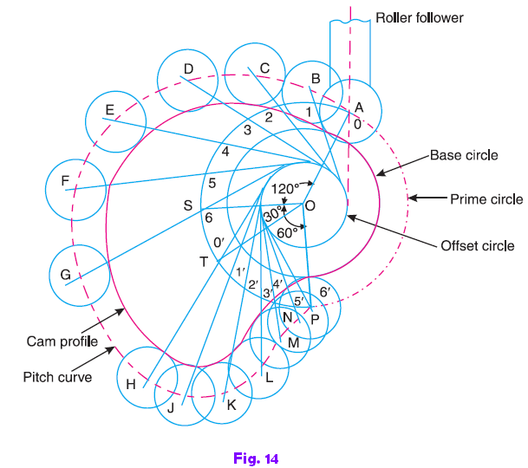
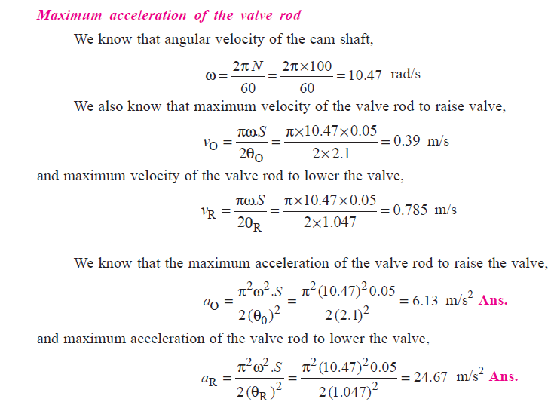

Home Work

A cam, with a minimum radius of 50 mm, rotating clockwise at a uniform speed, is required to give a knife edge follower the motion as described below:
- To move outwards through 40 mm during 100° rotation of the cam;
- To dwell for next 80°;
- To return to its starting position during next 90°, and
- To dwell for the rest period of a revolution i.e. 90°.
Draw the profile of the cam
- when the line of stroke of the follower passes through the centre of the cam shaft,
- when the line of stroke of the follower is off-set by 15 mm.
The displacement of the follower is to take place with uniform acceleration and uniform retardation. Determine the maximum velocity and acceleration of the follower when the cam shaft rotates at 900 r.p.m.
Draw the displacement, velocity and acceleration diagrams for one complete revolution of the cam.

