Chapter Four

Toothed Gearing

1. Introduction

The ***gears*** or ***toothed wheels*** are used to transmit power from one shaft to another. The slipping of a belt or rope is a common phenomenon in the transmission of motion or power between two shafts. The effect of slipping is to reduce the velocity ratio of the system. In precision machines, in which a definite velocity ratio is of importance (as in watch mechanism), the only positive drive is by means of ***gears*.** A gear drive is also provided, when the distance between the driver and the follower is very small.

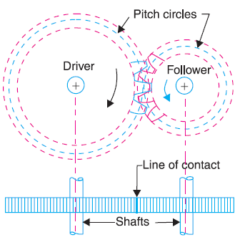



Fig. 1 Spur gear

1. Classification of Toothed Wheels (Gears)

The gears or toothed wheels may be classified as follows :

1. According to the position of axes of the shafts. The axes of the two shafts between which the motion is to be transmitted, may be
2. ***Parallel*** (spur gears, Fig. 1, and helical gears, Fig. 2(*a* and *b*).
3. ***Intersecting*** (bevel gears, Fig. 2*c*), and
4. ***Non-intersecting and non-parallel*** (spiral gears, Fig. 2*d*).

The worm gearing is essentially a form of spiral gearing in which the shafts are usually at right angles.

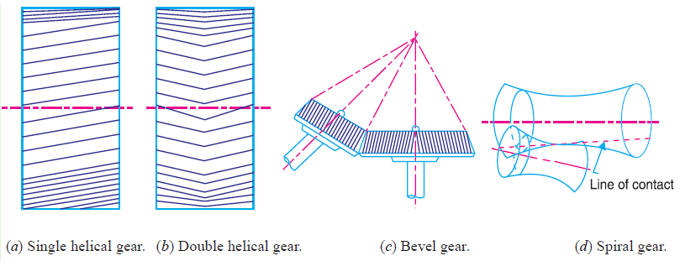

Fig. 2

1. According to the peripheral velocity of the gears. The gears according to the peripheral velocity of the gears may be classified as :

***(a)*** Low velocity, ***(b)*** Medium velocity, and ***(c)*** High velocity.

1. According to the type of gearing. The gears, according to the type of gearing may be classified as :
2. External gearing, Fig. 3*a*,
3. Internal gearing, Fig. 3*b*, and
4. Rack and pinion. Fig. 3*c*.
5. According to position of teeth on the gear surface. The teeth on the gear surface may be

***(a)*** straight, ***(b)*** inclined, and ***(c)*** curved.

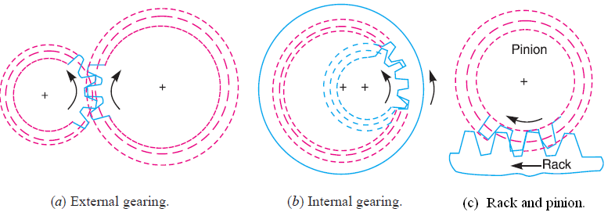

Fig. 3

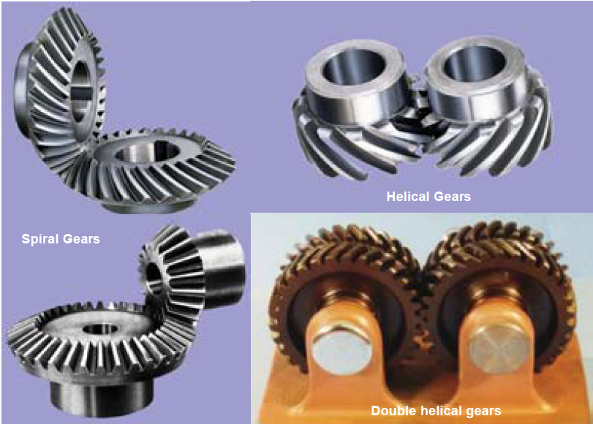



1. **Terms Used in Gears**
2. ***Pitch circle*.** It is an imaginary circle which by pure rolling action, would give the same motion as the actual gear.
3. ***Pitch circle diameter*.** It is the diameter of the pitch circle. The size of the gear is usually specified by the pitch circle diameter or ***pitch diameter*.**
4. ***Pitch point*.** It is a common point of contact between two pitch circles.
5. ***Pressure angle or angle of obliquity*.** It is the angle between the common normal to two gear teeth at the point of contact and the common tangent at the pitch point. It is usually denoted by φ. The standard pressure angles are 14 $\frac{1}{2}$ ° and 20°.

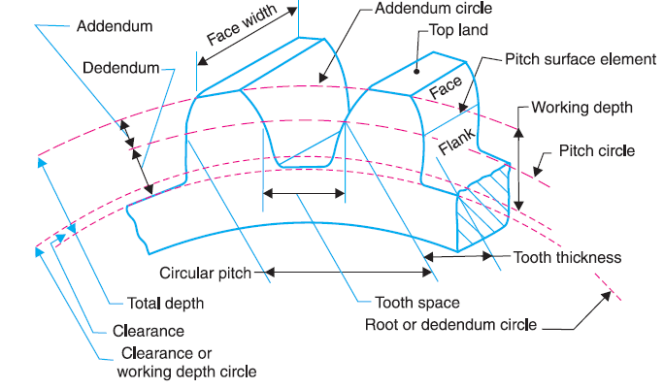

Fig. 4

1. ***Addendum*.** It is the radial distance of a tooth from the pitch circle to the top of the tooth.
2. ***Dedendum*.** It is the radial distance of a tooth from the pitch circle to the bottom of the tooth.
3. ***Addendum circle*.** It is the circle drawn through the top of the teeth and is concentric with the pitch circle.
4. ***Dedendum circle*.** It is the circle drawn through the bottom of the teeth. It is also called root circle.
5. ***Circular pitch*.** It is the distance measured on the circumference of the pitch circle from a point of one tooth to the corresponding point on the next tooth. It is usually denoted by *pc*.

Circular pitch, *pc* = π *D/T*

Where  *D* = Diameter of the pitch circle, and

*T* = Number of teeth on the wheel.

**Notes :** **1.** If the two gears are meshed together, they have the same circular pitch.

1. If *D*1 and *D*2 are the diameters of the two meshing gears having the teeth *T*1 and *T*2 respectively, then for them to mesh correctly,

*pc* = $\frac{π D_{1}}{T_{1}}$ = $\frac{π D_{1}}{T_{1}}$ or $\frac{ D_{1}}{D_{2}}$ = $\frac{ T_{1}}{T_{2}}$

1. ***Diametral pitch.*** It is the ratio of number of teeth to the pitch circle diameter. It is denoted by *pd* .

Diametral pitch, *pd* =

where *T* = Number of teeth, and

*D* = Pitch circle diameter.

1. ***Module*.** It is the ratio of the pitch circle diameter to the number of teeth. It is usually denoted by *m*.

Module, *m* = *D* /*T*

1. ***Clearance*.** It is the radial distance from the top of the tooth to the bottom of the tooth, in a meshing gear. A circle passing through the top of the meshing gear is known as ***clearance circle*.**
2. ***Total depth*.** It is the radial distance between the addendum and the dedendum circles of a gear. It is equal to the sum of the addendum and dedendum.
3. **Condition for Constant Velocity Ratio of Toothed Wheels–Law of Gearing**

Consider the portions of the two teeth, one on the wheel 1 (or pinion) and the other on the wheel 2, as shown by thick line curves in Fig. 5. Let the two teeth come in contact at point *Q*, and the wheels rotate in the directions as shown in the figure.

Let *T T* be the common tangent and *MN* be the common normal to the curves at the point of contact *Q*. From the centers *O*1 and *O*2, draw *O*1*M* and *O*2*N* perpendicular to *MN*. A little consideration will show that the point *Q* moves in the direction *QC*, when considered as a point on wheel 1, and in the direction *QD* when considered as a point on wheel 2.

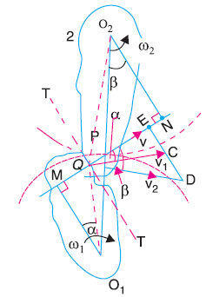

**Fig. 5** Law of gearing.

Let *v*1 and *v*2 be the velocities of the point *Q* on the wheels 1 and 2 respectively. If the teeth are to remain in contact, then the components of these velocities along the common normal *MN* must be equal.

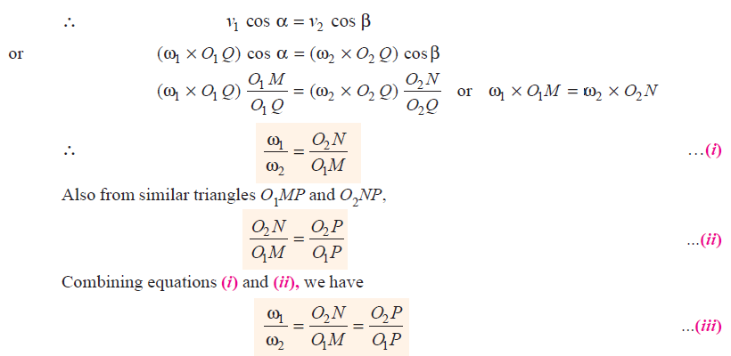

= $\frac{D_{2}}{D_{1}}$

1. **Velocity of Sliding of Teeth**

The sliding between a pair of teeth in contact at *Q* occurs along the common tangent *T T* to the tooth curves as shown in Fig. 5. ***The velocity of sliding is the velocity of one tooth relative to*** ***its mating tooth along the common tangent at the point of contact***.

Let *v*S = Velocity of sliding at *Q*.

*v*S = (ω1 + ω2 )*QP*

**Note:** The velocity of sliding is proportional to the distance of the point of contact from the pitch point.

1. **Length of Path of Contact**

The length of path of contact is the length of common normal cutoff by the addendum circles of the wheel and the pinion. Consider a pinion driving the wheel as shown in Fig. 6. Thus the length of path of contact is *KL* which is the sum of the parts of the path of contacts *KP* and *PL*.

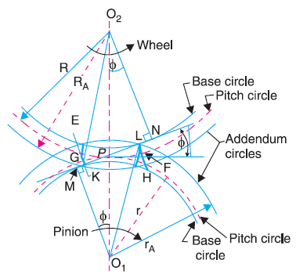

Fig . 6

Let  *r*A = *O*1*L* = Radius of addendum circle of pinion,

*R*A = *O*2*K* = Radius of addendum circle of wheel,

*r* = *O*1*P* = Radius of pitch circle of pinion, and

*R* = *O*2*P* = Radius of pitch circle of wheel.

*KP* = $\sqrt{R_{A}^{2}- R^{2}\cos{φ^{2}} }$– *R $\sin{φ}$*

*PL* = $\sqrt{r_{A}^{2}- r^{2}\cos{φ^{2}} }$– *r $\sin{φ}$*

*KL* = *KP* + *PL* = $\sqrt{R_{A}^{2}- R^{2}\cos{φ^{2}} }$ + $\sqrt{r_{A}^{2}- r^{2}\cos{φ^{2}} }$– (*R* + *r*) $\sin{φ}$

1. **Length of Arc of Contact**

We have already defined that the arc of contact is the path traced by a point on the pitch circle from the beginning to the end of engagement of a given pair of teeth. In Fig. 6, the arc of contact is *EPF* or *GPH*.

Length of the arc of contact = $\frac{Length of path of contact}{\cos{φ}}$

1. **Contact Ratio**

The contact ratio or the number of pairs of teeth in contact is defined as the ***ratio of the length of the arc of contact to the circular pitch.***

Contact ratio or number of pairs of teeth in contact = $\frac{Length of the arc of contact}{Pc}$

where *pc* = Circular pitch = π*m*, and

*m* = Module.

**Example: 1**

Two involute gears of 20° pressure angle are in mesh. The number of teeth on pinion is 20 and the gear ratio is 2. If the pitch expressed in module is 5 mm and the pitch line speed is 1.2 m/s, assuming addendum as standard and equal to one module, find:

1. The angle turned through by pinion when one pair of teeth is in mesh ; and
2. The maximum velocity of sliding.

Solution: Given : φ = 20° ; *t* = 20; *G* = *T*/*t* = 2; *m* = 5 mm ; *v* = 1.2 m/s ; addendum = 1 module = 5 mm

**1. *Angle turned through by pinion when one pair of teeth is in mesh***

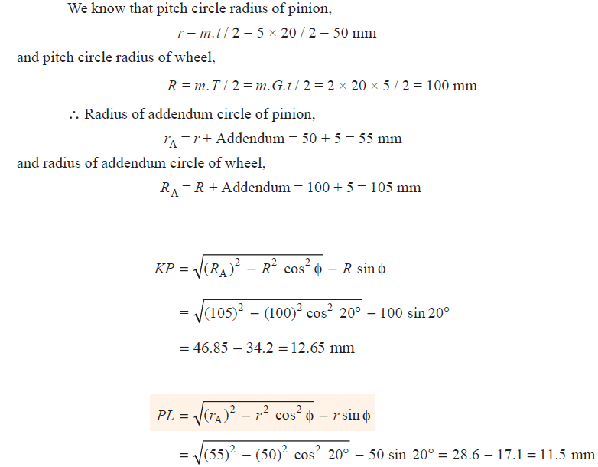



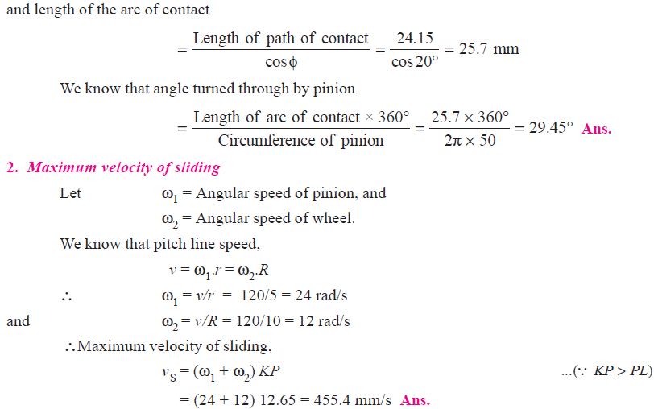

**Home Work**

A pinion having 30 teeth drives a gear having 80 teeth. The profile of the gears is involute with 20° pressure angle, 12 mm module and 10 mm addendum. Find the length of path of contact, arc of contact and the contact ratio.