Gear Trains
- Introduction
Sometimes, two or more gears are made to mesh with each other to transmit power from one shaft to another. Such a combination is called gear train or train of toothed wheels. The nature of the train used depends upon the velocity ratio required and the relative position of the axes of shafts. A gear train may consist of spur, bevel or spiral gears.

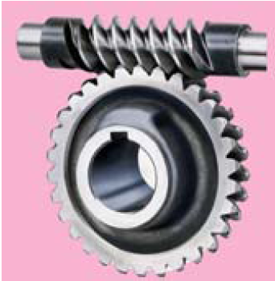

- Types of Gear Trains
Following are the different types of gear trains, depending upon the arrangement of wheels :
- Simple gear train,
- Compound gear train,
- Reverted gear train, and
- Epicyclic gear train.

- Simple Gear Train
When there is only one gear on each shaft, as shown in Fig. 1, it is known as simple gear train.
Speed ratio (or velocity ratio) = $\frac{N_{1}}{N_{2}}$ = $\frac{T_{2}}{T_{1}}$
Sometimes, the distance between the two gears is large. The motion from one gear to another, in such a case, may be transmitted by either of the following two methods: 1. By providing the large sized gear, or 2. By providing one or more intermediate gears idle gears.
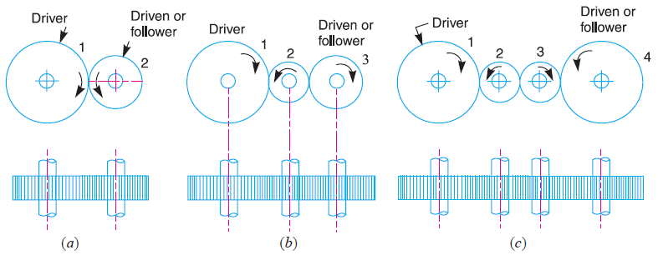
Fig. 1. Simple gear train.
Now consider a simple train of gears with one intermediate gear as shown in Fig. 1 (b).
Speed ratio for two gears 1 & 2 is $\frac{N_{1}}{N_{2}}$ = $\frac{T_{2}}{T_{1}}$ ……(i)

Similarly, speed ratio for two gears 2 & 3 is $\frac{N_{2}}{N_{3}}$ = $\frac{T_{3}}{T_{2}}$ ……(ii)
The speed ratio of the gear train is obtained by multiplying the equations (i) and (ii).
$\frac{N_{1}}{N_{2}}$ × $\frac{N_{2}}{N_{3}}$ = $\frac{T_{2}}{T_{1}}$ × $\frac{T_{3}}{T_{2}}$ or $\frac{N_{1}}{N_{3}}$ = $\frac{T_{3}}{T_{1}}$
i.e. Speed ratio = $\frac{ Speed of driver }{ Speed of driven }$ = $\frac{ No. of teeth on driven or follower }{ No. of teeth on driver }$

- Compound Gear Train
When there are more than one gear on a shaft, as shown in Fig .2, it is called a compound train of gear.
The speed ratio of compound gear train is $\frac{N_{1}}{N_{6}}$ = $\frac{{ T}_{2 }× T_{4} × T_{6 }}{{ T}_{1} × T_{3} × T_{5 }}$
i.e. Speed ratio = $\frac{ Speed of the first driver }{ Speed of the last driven or follower }$
= $\frac{ Product of the number of teeth on the followers}{ Product of the number of teeth on the drivers }$
Note: Since gears 2 and 3 are mounted on one shaft B, therefore N₂ = N₃. Similarly gears 4 and 5 are mounted on shaft C, therefore N₄ = N₅.

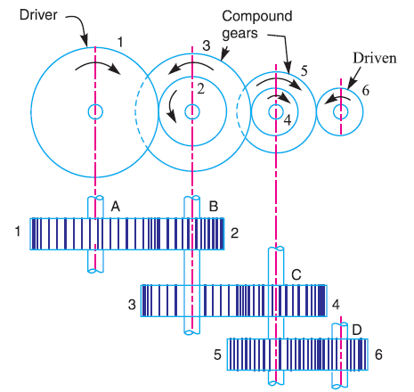
Fig. 2. Compound gear train.

- Reverted Gear Train
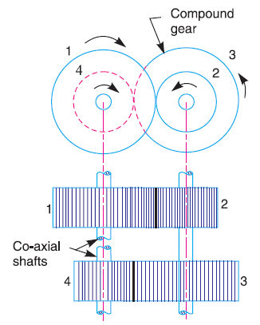
Fig. 3. Reverted gear train.
When the axes of the first gear (i.e. first driver) and the last gear (i.e. last driven or follower) are co-axial, then the gear train is known as reverted gear train as shown in Fig. 3.

Since the distance between the centers of the shafts of gears 1 and 2 as well as gears 3 and 4 is same, therefore
r₁ + r₂ = r₃ + r₄
Also, the circular pitch or module of all the gears is assumed to be same
T₁ + T₂ = T₃ + T₄
Speed ratio = $\frac{ Product of the number of teeth on the follower}{ Product of the number of teeth on the drivers }$
$\frac{N_{1}}{N_{4}}$ = $\frac{{ T}_{2 }× T_{4} }{{ T}_{1} × T_{3} }$
Example: 1
The gearing of a machine tool is shown in Fig. 4. The motor shaft is connected to gear A and rotates at 975 r.p.m. The gear wheels B, C, D and E are fixed to parallel shafts rotating together. The final gear F is fixed on the output shaft. What is the speed of gear F ? The number of teeth on each gear are as given below :
Gear A B C D E F
No. of teeth 20 50 25 75 26 65
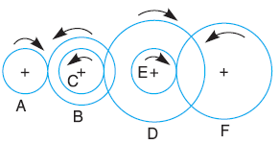
Solution:
$\frac{N_{A}}{N_{F}}$ = $\frac{{ T}_{B }× T_{D} × T_{F }}{{ T}_{A} × T_{C} × T_{E }}$ = $\frac{50 × 75 × 65}{20 × 25 × 26}$ = 18.75
∴ N_{F} = $\frac{N_{A}}{18.75}$ = $\frac{975}{18.75}$ = 52 r.p.m.

Fig .4
- Epicyclic Gear Train
In this type of gear trains, the axes of the shafts, over which the gears are mounted, may move relative to a fixed axis. A simple epicyclic gear train is shown in Fig. 5. The tabular method may be used for finding out the velocity ratio of an epicyclic gear train (see Table.1).

Let :
T_{A} = Number of teeth on gear A, and
T_{B} = Number of teeth on gear B.
N_{A} = Velocity of gear A
N_{B} = Velocity of gear B
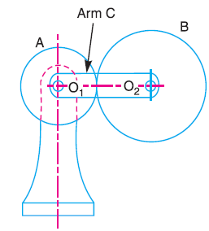
Fig. 5. Epicyclic gear train.
Table .1. Table of motions
 |  | Revolutions of elements
Step No. | Conditions of motion | Arm C | Gear A | Gear B
 | Add (+ a) revolutions to all elements | + a | + a | + a
 | Arm fixed , gear A rotates through (+ b) revolutions | 0 | + b | - b $\frac{T_{A}}{T_{B}}$
 | Total motion | +$a$ | $a$ + $b$ | $a$ – $b$ $\frac{T_{A}}{T_{B}}$

Assuming the anticlockwise rotation as positive and clockwise as negative.
According to the final results and the information given, we can find the values of (a) and (b) and then, N_{A} and N_{B}.
Example: 2
In an epicyclic gear train, an arm carries two gears A and B having 36 and 45 teeth respectively. If the arm rotates at 150 r.p.m. in the anticlockwise direction about the centre of the gear A which is fixed, determine the speed of gear B. If the gear A instead of being fixed, makes 300 r.p.m. in the clockwise direction, what will be the speed of gear B ?
Solution:

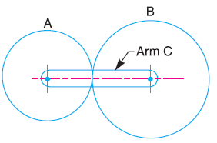Table : 2 Table of motions.
 |  | Revolutions of elements
Step No. | Conditions of motion | Arm C | Gear A | Gear B
 | Add (+ a) revolutions to all elements | + a | + a | + a
 | Arm fixed , gear A rotates through (+ b) revolutions | 0 | + b | - b $\frac{T_{A}}{T_{B}}$
 | Total motion | +$a$ | $a$ + $b$ | $a$ – $b$ $\frac{T_{A}}{T_{B}}$

- Speed of gear B when gear A is fixed
Since the speed of arm is 150 r.p.m. anticlockwise, therefore from the third row of the table, ∴ a = 150 r.p.m
The velocity of gear A = 0 (fixed)
a + b = 0 or a = – b = – 150 r.p.m
Speed of gear B, N_{B} = $a$ – $b$ $\frac{T_{A}}{T_{B}}$ = 150 – 150 × $\frac{36}{45}$ = + 270 r.p.m
= 270 r.p.m. (anticlockwise) Ans.
- Speed of gear B when gear A makes 300 r.p.m. clockwise
Since the gear A makes 300 r.p.m. clockwise, therefore from the third row of the table,
a + b = – 300 or b = –300 – a = –300 – 150 = – 450 r.p.m
N_{B} = $a$ – $b$ $\frac{T_{A}}{T_{B}}$ = 150 + 450 × $\frac{36}{45}$ = + 510 r.p.m
= 510 r.p.m. (anticlockwise) Ans.

Example: 3
In a reverted epicyclic gear train, the arm A carries two gears B and C and a compound gear D - E. The gear B meshes with gear E and the gear C meshes with gear D. The number of teeth on gears B, C and D are 75, 30 and 90 respectively. Find the speed and direction of gear C when gear B is fixed and the arm A makes 100 r.p.m. clockwise.
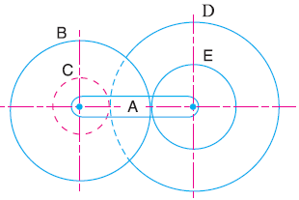
Solution:
The reverted epicyclic gear train is shown in Fig. 6.
T_{B} + T_{E} = T_{C} + T_{D}
∴ T_{E} = T_{C} + T_{D} – T_{B} = 30 + 90 – 75 = 45
Fig. 6
Table: 3. Table of motions.
 |  | Revolutions of elements
Step No. | Conditions of motion | Arm A | Compound Gear D-E | Gear B | Gear C
 | Add (+ a) revolutions to all elements | + a | + a | + a | + a
 | Arm fixed , compound gear D-E rotates through (+ b) revolutions | 0 | + b | – $b×$ $\frac{T_{E}}{T_{B}}$ | – b× $\frac{T_{D}}{T_{C}}$
 | Total motion | +$a$ | a + b | $a$ – $b×\frac{T_{E}}{T_{B}}$ | $a$ – $b$ × $\frac{T_{D}}{T_{C}}$

The arm A makes 100 r.p.m. clockwise, therefore a = – 100
Since the gear B is fixed, therefore from the third row of the table,
$a$ – $b ×\frac{T_{E}}{T_{B}}$ = 0 or $–100$ – $b ×\frac{45}{75}$ = 0
b = – 166.67
Speed of gear C, N_{C} = $a$ – $b$ × $\frac{T_{D}}{T_{C}}$ = – 100 + 166.67 × $\frac{90}{30}$ = + 400 r.p.m.
= 400 r.p.m. (anticlockwise) Ans.
Example: 4
An epicyclic gear consists of three gears A, B and C as shown in Fig. 7. The gear A has 72 internal teeth and gear C has 32 external teeth. The gear B meshes with both A and C and is carried on an arm EF which rotates about the centre of A at 18 r.p.m.. If the gear A is fixed, determine the speed of gears B and C.
Solution: Table: 4. Table of motions.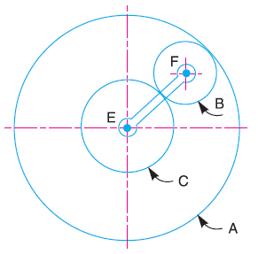
Fig. 7
 |  | Revolutions of elements
Step No. | Conditions of motion | Arm EF | Gear C | Gear B | Gear A
 | Add (+ a) revolutions to all elements | + a | + a | + a | + a
 | Arm fixed , gear C rotates through (+ b) revolutions | 0 | + b | – $b×$ $\frac{T_{C}}{T_{B}}$ | – b× $\frac{T_{C}}{T_{B}}$ $×$ $\frac{T_{B}}{T_{A}}$ = – b × $\frac{T_{C}}{T_{A}}$
 | Total motion | +$a$ | a + b | $a$ – $b×\frac{T_{C}}{T_{B}}$ | $a$ – $b$ × $\frac{T_{C}}{T_{A}}$

Speed of gear C
The speed of the arm is 18 r.p.m. therefore, a = 18 r.p.m.
and the gear A is fixed, therefore $a$ – $b$ × $\frac{T_{C}}{T_{A}}$ = 0 or 18 – $b$ × $\frac{32}{72}$ = 0 , ∴ b=40.5
Speed of gear C = a + b = 40.5 + 18 = + 58.5 r.p.m.
= 58.5 r.p.m. in the direction of arm. Ans.
Speed of gear B
d_{B} + $\frac{d_{C}}{2}$ = $\frac{d_{A}}{2}$ 2 T_{B} + T_{C} = T_{A} or 2 T_{B} + 32 = 72 or T_{B} = 20
∴ Speed of gear B =$a$ – $b×\frac{T_{C}}{T_{B}}$ = 18 – 40.5 = – 46.8 r.p.m.
= 46.8 r.p.m. in the opposite direction of arm. Ans.
Torques in Epicyclic Gear Trains
When the rotating parts of an epicyclic gear train, as shown in Fig. 1, have no angular acceleration, the gear train is kept in equilibrium by the three externally applied torques, viz.
- Input torque on the driving member (T₁),
- Output torque or resisting or load torque on the driven member (T₂),
- Holding or braking or fixing torque on the fixed member (T₃).
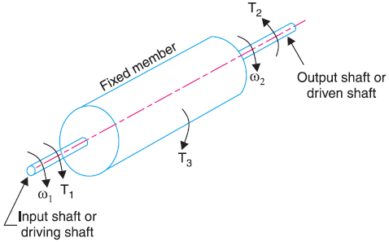
Fig. 1. Torques in epicyclic gear trains.
T₁ + T₂ + T₃ = 0
∴ F₁.r₁ + F₂.r₂ + F₃.r₃ = 0
T₁.ω₁ + T₂.ω₂ + T₃.ω₃ = 0 (Kinetic Energy Balance)
But, for a fixed member, ω₃ = 0
∴ T₁.ω₁ + T₂.ω₂ = 0
Example: 1 In the epicyclic gear train, as shown in Fig. 2, the driving gear A rotating in clockwise direction has 14 teeth and the fixed annular gear C has 100 teeth. The ratio of teeth in gears E and D is 98:41. If 1.85 kW is supplied to the gear A rotating at 1200 r.p.m., find:
- the speed and direction of rotation of gear E, and
- the fixing torque required at C, assuming 100 per cent efficiency throughout and that all teeth have the same pitch.
Solution:
d_{A} + 2d_{B} = d_{C} (pitch circle diameters)
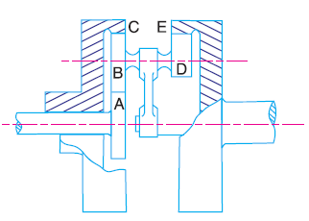
T_{A} + 2T_{B} = T_{C}
T_{B} = $\frac{T_{C}- T_{A}}{2}$ = $\frac{100-14}{2}$ = 43

 |  | Revolutions of elements
Step No. | Conditions of motion | Arm | Gear A | Compound gear B-D | Gear C | Gear E
 | Add (+ a) revolutions to all elements | + a | + a | + a | + a | + a
 | Arm fixed , gear A rotates through (+ b) revolutions | 0 | + b | – $b×$ $\frac{T_{A}}{T_{B}}$ | – b× $\frac{T_{A}}{T_{B}}$ $×$ $\frac{T_{B}}{T_{C}}$ = – b × $\frac{T_{A}}{T_{C}}$ | – $b×$ $\frac{T_{A}}{T_{B}}$×$\frac{T_{D}}{T_{E}}$
 | Total motion | +$a$ | a + b | $a$ – $b×\frac{T_{A}}{T_{B}}$ | $a$ – $b$ × $\frac{T_{A}}{T_{C}}$ | a– $b×$ $\frac{T_{A}}{T_{B}}$×$\frac{T_{D}}{T_{E}}$

Since the annular gear C is fixed, therefore from the table,
$a$ – $b$ × $\frac{T_{A}}{T_{C}}$ = 0 or $a$ – $b$ × $\frac{14}{100}$ = 0
∴ $a$ – 0.14 b = 0
Also, the gear A is rotating at 1200 r.p.m., therefore
a + b = 1200
b = 1052.6, and a = 147.4

