Belt and Rope Drives
- Introduction
The belts or ropes are used to transmit power from one shaft to another by means of pulleys which rotate at the same speed or at different speeds.

- Types of Belts

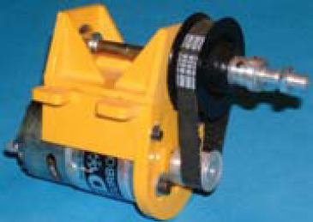
- Flat belt is mostly used in the factories and workshops, where a moderate amount of power is to be transmitted, from one pulley to another when the two pulleys are not more than 8 metres apart.
- V-belt is mostly used in the factories and workshops, where a moderate amount of power is to be transmitted, from one pulley to another, when the two pulleys are very near to each other.
- Circular belt or rope is mostly used in the factories and workshops, where a great amount of power is to be transmitted, from one pulley to another, when the two pulleys are more than 8 meters apart.
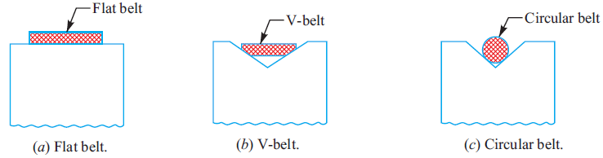
- Types of Flat Belt Drives
The power from one pulley to another may be transmitted by any of the following types of belt drives:
- Open belt drive. The open belt drive, as shown in Fig. 1, is used with shafts arranged parallel and rotating in the same direction. The tension in tight side is more than the tension in slack side.
- Crossed or twist belt drive. The crossed or twist belt drive, as shown in Fig.2, is used with shafts arranged parallel and rotating in the opposite directions.
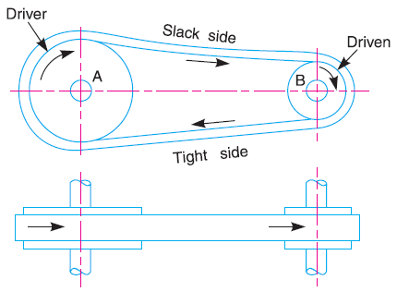
Fig. 1. Open belt drive.
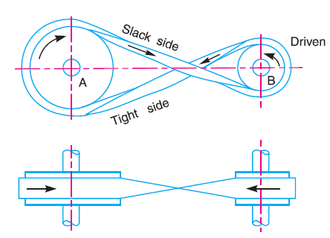
Fig. 2. Crossed or twist belt drive.
In order to avoid the wear in the belt intersection the shafts should be placed at a maximum distance of 20 b, where b is the width of belt and the speed of the belt should be less than 15 m/s.
- Quarter turn belt drive. The quarter turn belt drive also known as right angle belt drive, as shown in Fig. 3, is used with shafts arranged at right angles and rotating in one definite direction.
- Belt drive with idler pulleys. A belt drive with an idler pulley, as shown in Fig.4, is used with shafts arranged parallel and when an open belt drive cannot be used due to small angle of contact on the smaller pulley. This type of drive is provided to obtain high velocity ratio and when the required belt tension cannot be obtained by other means.

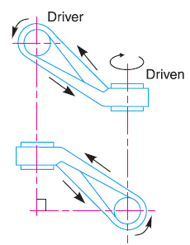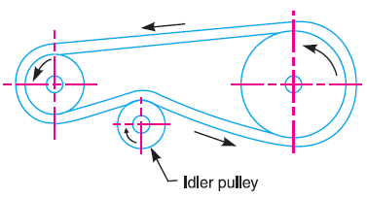
Fig. 3 Quarter turn belt drive. Fig. 4 Belt drive with single idler pulley.
- Compound belt drive. A compound belt drive, as shown in Fig. 5, is used when power is transmitted from one shaft to another through a number of pulleys.
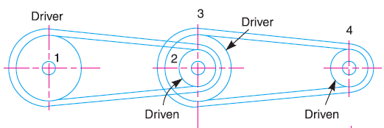
Fig .5. Compound belt drive.
- Stepped or cone pulley drive. A stepped or cone pulley drive, as shown in Fig.6, is used for changing the speed of the driven shaft while the main or driving shaft runs at constant speed. This is accomplished by shifting the belt from one part of the steps to the other.
- Fast and loose pulley drive. A fast and loose pulley drive, as shown in Fig. 7, is used when the driven or machine shaft is to be started or stopped when ever desired without interfering with the driving shaft. A pulley which is keyed to the machine shaft is called fast pulley and runs at the same speed as that of machine shaft. A loose pulley runs freely over the machine shaft and is incapable of transmitting any power. When the driven shaft is required to be stopped, the belt is pushed on to the loose pulley by means of sliding bar having belt forks.
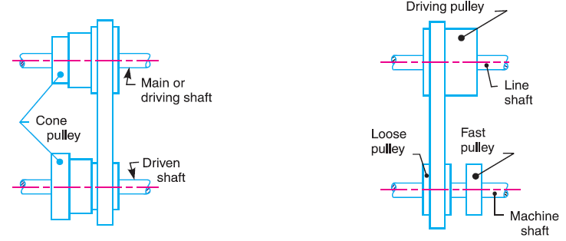
Fig. 6. Stepped or cone pulley drive. Fig. 7. Fast and loose pulley drive.
- Velocity Ratio of Belt Drive
It is the ratio between the velocities of the driver and the follower or driven. It may be expressed, mathematically, as:
$\frac{N_{2}}{N_{1}}$ = $\frac{d_{1}}{d_{2}}$
Where d₁ = Diameter of the driver,
d₂ = Diameter of the follower,
N₁ = Speed of the driver in r.p.m., and
N₂ = Speed of the follower in r.p.m.
When the thickness of the belt (t) is considered, then velocity ratio,
$\frac{N_{2}}{N_{1}}$ = $\frac{d_{ 1}+ t}{d_{ 2+t}}$
- Velocity Ratio of a Compound Belt Drive
Sometimes the power is transmitted from one shaft to another, through a number of pulleys as shown in Fig. 5.
We know that velocity ratio of pulleys 1 and 2,
$\frac{N_{2}}{N_{1}}$ = $\frac{d_{1}}{d_{2}}$ i
Similarly, velocity ratio of pulleys 3 and 4,
$\frac{N_{4}}{N_{3}}$ = $\frac{d_{3}}{d_{4}}$ ii
Multiplying equations (i) and (ii),
$\frac{N_{4}}{N_{1}}$ = $\frac{d_{1}{ × d}_{3 }}{d_{2} × d_{4}}$ (N₂ = N₃, because of the same shaft)
or $\frac{Speed of last driven}{Speed of first driver}$= $\frac{Product of diameters of drivers}{Product of diameters of drivens}$

- Slip of Belt
In the previous articles, we have discussed the motion of belts and shafts assuming a firm frictional grip between the belts and the shafts. But sometimes, the frictional grip becomes insufficient. This may cause some forward motion of the driver without carrying the belt with it. This may also cause some forward motion of the belt without carrying the driven pulley with it. This is called slip of the belt and is generally expressed as a percentage.
The result of the belt slipping is to reduce the velocity ratio of the system. As the slipping of the belt is a common phenomenon, thus the belt should never be used where a definite velocity ratio is of importance (as in the case of hour, minute and second arms in a watch).
Let s₁ % = Slip between the driver and the belt, and
s₂ % = Slip between the belt and the follower.
Velocity of the belt passing over the driver per second
v = $\frac{π d_{1} N_{1}}{60}$ – $\frac{π d_{1} N_{1}}{60}$ $× \frac{s_{1}}{100}$ = $\frac{π d_{1} N_{1}}{60}$ (1 – $\frac{s_{1}}{100}$)
and velocity of the belt passing over the follower per second,
$\frac{π d_{2} N_{2}}{60}$ = v – v × $\frac{s_{2}}{100}$ = v (1 – $\frac{s_{2}}{100}$)
$\frac{π d_{2} N_{2}}{60}$ = $\frac{π d_{1} N_{1}}{60}$ (1 – $\frac{s_{1}}{100}$) (1 – $\frac{s_{2}}{100}$)
$\frac{N_{2}}{N_{1}}$ = $\frac{d_{1}}{d_{2}}$ (1 – $\frac{s_{1}}{100}$ – $\frac{s_{2}}{100}$) (neglecting $\frac{s_{1}× s_{2}}{100 × 100}$ )
= $\frac{d_{1}}{d_{2}}$ (1 – $\frac{s_{1+ }s_{2}}{100}$ ) = $\frac{d_{1}}{d_{2}}$ (1 – $\frac{s}{100}$ )
Where s = s₁ + s₂ total percentage of slip.
If thickness of the belt (t) is considered, then
$\frac{N_{2}}{N_{1}}$ = $\frac{d_{1}+ t}{d_{2}+ t}$ (1 – $\frac{s}{100}$ )

- Creep of Belt
When the belt passes from the slack side to the tight side, a certain portion of the belt extends and it contracts again when the belt passes from the tight side to slack side. Due to these changes of length, there is a relative motion between the belt and the pulley surfaces. This relative motion is termed as creep. The total effect of creep is to reduce slightly the speed of the driven pulley or follower. Considering creep, the velocity ratio is given by
$\frac{N_{2}}{N_{1}}$ = $\frac{d_{1}}{d_{2}}$ $×$ $\frac{E+ \sqrt{σ_{2}} }{E+ \sqrt{σ_{1}}}$
Where σ₁ and σ₂ = Stress in the belt on the tight and slack side respectively, and
E = Young’s modulus for the material of the belt.
- Length of an Open Belt Drive
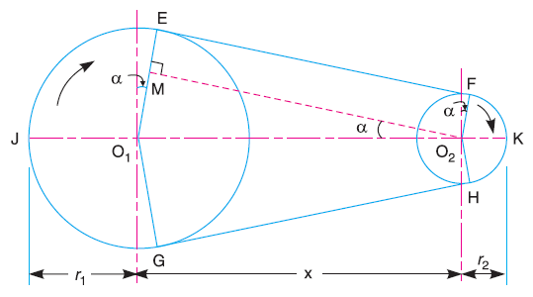
In this case, both the pulleys rotate in the same direction.
Let r₁ and r₂ = Radii of the larger and smaller pulleys,
X = Distance between the centers of two pulleys (i.e. O₁ O₂), and
L = Total length of the belt.
Fig. 8. Length of an open belt drive.
Let the belt leaves the larger pulley at E and G and the smaller pulley at F and H as shown in Fig. 10. Through O₂, draw O₂ M parallel to FE.
From the geometry of the figure, we find that O₂ M will be perpendicular to O₁ E.
Let the angle MO₂ O₁ = α radians.
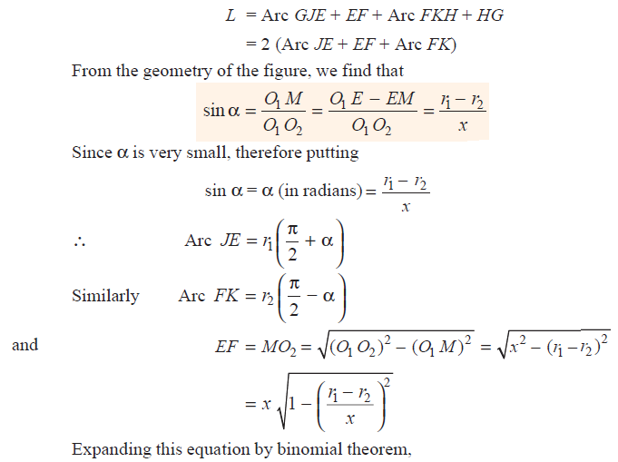
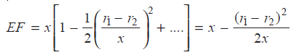
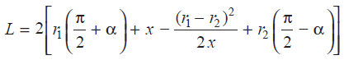
Since α = $\frac{r_{1}- r_{2}}{x}$ then
L = π (r₁ + r₂) + 2x + $\frac{{{(r}_{1}- r_{2})}^{2}}{x}$

- Length of a Cross Belt Drive
In this case, both the pulleys rotate in opposite directions as shown in Fig. 1.
Let r₁ and r₂ = Radii of the larger and smaller pulleys,
X = Distance between the centers of two pulleys (i.e. O₁ O₂), and
L = Total length of the belt.
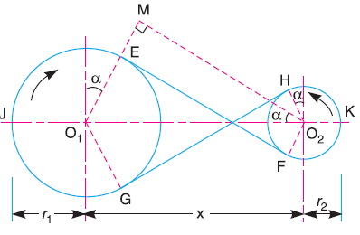
Let the belt leaves the larger pulley at E and G and the smaller pulley at F and H. Through O₂, draw O₂M parallel to FE. From the geometry of the figure, we find that O₂M will be perpendicular to O₁E.
Let the angle MO₂O₁ = α radians.

Fig. 1. Length of a cross belt drive.

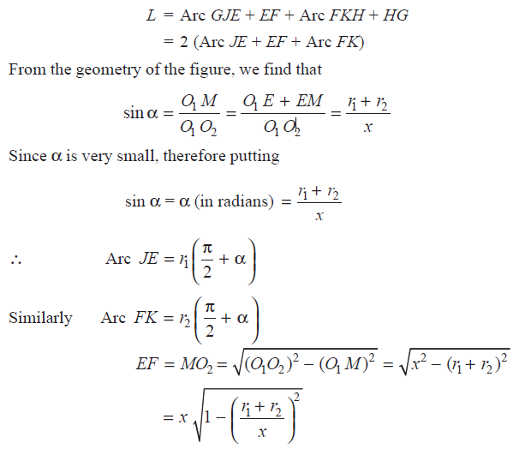
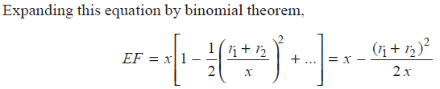
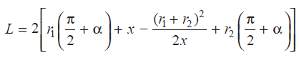
Substituting the value of α = $\frac{r_{1}+ r_{2}}{x}$ then
L = π (r₁ + r₂) + 2x + $\frac{{{(r}_{1}+ r_{2})}^{2}}{x}$
- Power Transmitted by a Belt
Let T₁ and T₂ = Tensions in the tight and slack side of the belt respectively in N,
r₁ and r₂ = Radii of the driver and follower respectively, and
v = Velocity of the belt in m/s.
∴ Work done per second = (T₁ – T₂) v N-m/s
and power transmitted, P = (T₁ – T₂) v Watt
- Ratio of Driving Tensions For Flat Belt Drive
Consider a driven pulley rotating in the clockwise direction as shown in Fig. 2.
Let T₁ = Tension in the belt on the tight side,
T₂ = Tension in the belt on the slack side, and
θ = Angle of contact in radians.
Now consider a small portion of the belt PQ, subtending an angle δθ at the centre of the pulley. The belt PQ is in equilibrium under the following forces:
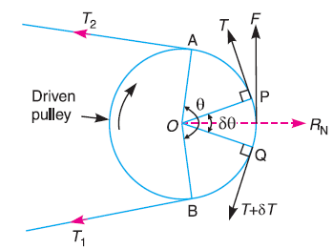
- Tension T in the belt at P,
- Tension (T + δ T) in the belt at Q,
- Normal reaction R_{N}, and
- Frictional force, F = μ × R_{N} ,
where μ is the coefficient of friction
Fig .2
between the belt and pulley.
Σ F_{x} = 0
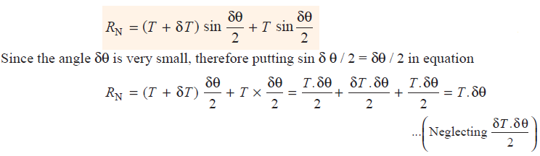
Σ F_{y} = 0 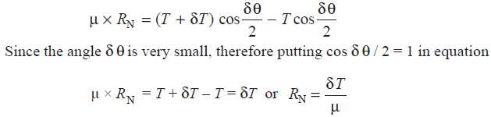
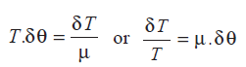
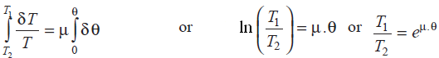

- Determination of Angle of Contact
The angle of contact or lap in open belt drives:
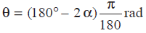 sinα = $\frac{r_{1}- r_{2}}{x}$
The angle of contact or lap in crossed belt drives:
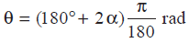 sinα = $\frac{r_{1}+ r_{2}}{x}$
- Maximum Tension in the Belt
The maximum tension in the belt (T _{max}) is equal to the total tension in the tight side of the belt (Tt₁).
Let σ_{max} = Maximum safe stress in N/mm²,
b = Width of the belt in mm, and
t = Thickness of the belt in mm.
We know that maximum tension in the belt,
T_{max} = σ_{max} . b. t
When centrifugal tension is neglected, then
T_{max} = T₁
and when centrifugal tension is considered, then
T_{max} = T₁ + T_{C}
- Condition For the Transmission of Maximum Power
P = (T₁ – T₂) v …. (i)
$\frac{T_{1}}{T_{2}}$ = $e^{μ . θ}$ or T₂ = $\frac{T_{1}}{e^{μ . θ}}$ .... (ii)
Substituting the value of T₂ in equation (i),
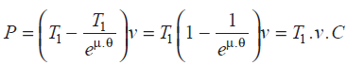 ….(iii)
Where C = 1 – $\frac{T_{1}}{e^{μ . θ}}$
But T₁ = T_{max} – T_{C}
P = (T_{max} – T_{C}) v . C
= (T_{max} – m.v²) v. C = (T. _{max} v – m v³) C ... (Substituting T_{C} = m. v²)
For maximum power, differentiate the above expression with respect to v and equate to zero, $\frac{dP}{dv}$ = 0 ∴ T_{max} – 3 m . v² = 0
T_{max} – 3 T_{C} = 0 or T_{max} = 3 T_{C}
Note: We know that T₁ = T_{max} – T_{C} and for maximum power, T_{C} = $\frac{T_{max}}{3}$
T₁ = T_{max} – $\frac{T_{max}}{3}$ = $\frac{{2T}_{max}}{3}$

Example: 1 A leather belt is required to transmit 7.5 kW from a pulley 1.2 m in diameter, running at 250 r.p.m. The angle embraced is 165° and the coefficient of friction between the belt and the pulley is 0.3. If the safe working stress for the leather belt is 1.5 MPa, density of leather 1 Mg/m³ and thickness of belt 10 mm, determine the width of the belt taking centrifugal tension into account.

Solution:

