Governors
- Introduction
The function of a governor is to regulate the mean speed of an engine, when there are variations in the load e.g. when the load on an engine increases, its speed decreases, therefore it becomes necessary to increase the supply of working fluid. On the other hand, when the load on the engine decreases, its speed increases and thus less working fluid is

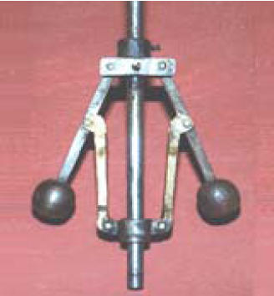
required. The governor automatically controls the supply of working fluid to the engine with the varying load conditions and keeps the mean speed within certain limits.
- Types of Governors
The governors may, broadly, be classified as
1. Centrifugal governors, and 2. Inertia governors.
The centrifugal governors, may further be classified as follows :

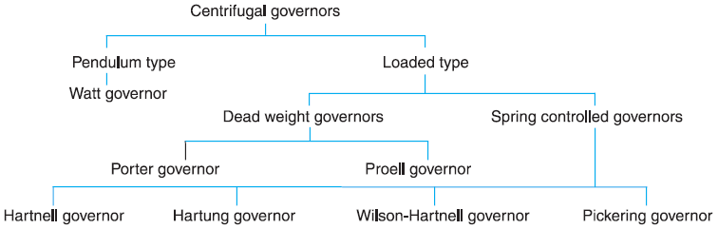

- Terms Used in Governors
The following terms used in governors;
- Height of a governor. It is the vertical distance from the center of the ball to a point where the axes of the arms (or arms produced) intersect on the spindle axis. It is usually denoted by h.
- Equilibrium speed. It is the speed at which the governor balls, arms etc., are in complete equilibrium and the sleeve does not tend to move upwards or downwards.
- Mean equilibrium speed. It is the speed at the mean position of the balls or the sleeve.
- Maximum and minimum equilibrium speeds. The speeds at the maximum and minimum radius of rotation of the balls, without tending to move either way are known as maximum and minimum equilibrium speeds respectively.
- Sleeve lift. It is the vertical distance which the sleeve travels due to change in equilibrium speed.
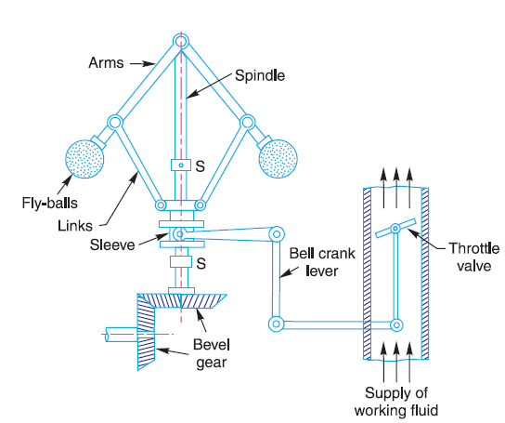
Fig .1. Centrifugal governor.
- Watt Governor
The simplest form of a centrifugal governor is a Watt governor, as shown in Fig.2. It is basically a conical pendulum with links attached to a sleeve of negligible mass. The arms of the governor may be connected to the spindle in the following three ways:
- The pivot P, may be on the spindle axis as shown in Fig .2 (a).
- The pivot P, may be offset from the spindle axis and the arms when produced intersect at O, as shown in Fig .2 (b).
- The pivot P, may be offset, but the arms cross the axis at O, as shown in Fig .2 (c).
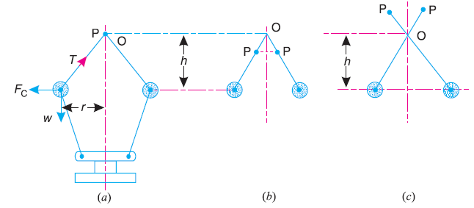
Fig .2. Watt governor.
Let m = Mass of the ball in kg,
w = Weight of the ball in newtons = m.g,
T = Tension in the arm in newtons,
ω = Angular velocity of the arm and ball about the spindle axis in
rad/s,
r = Radius of the path of rotation of the ball i.e. horizontal distance
from the center of the ball to the spindle axis in meters,
F_{C} = Centrifugal force acting on the ball in newtons = m.ω².r, and
h = Height of the governor in meters.
It is assumed that the weight of the arms, links and the sleeve are negligible as compared to the weight of the balls. Now, the ball is in equilibrium under the action of
1. the centrifugal force (F_{C}) acting on the ball,
2. the tension (T) in the arm, and
3. the weight (w) of the ball.
Taking moments about point O, we have
F_{C} × h = w × r = m.g.r
or m.ω².r.h = m.g.r or h = g /ω² ……. (1)
Note: Watt governor may only work satisfactorily at relatively low speeds i.e. from 60 to 80 r.p.m.

- Porter Governor
The Porter governor is a modification of a Watt governor, with central load attached to the sleeve as shown in Fig .3 (a). The load moves up and down the central spindle. This additional downward force increases the speed of revolution required to enable the balls to rise to any predetermined level.
Consider the forces acting on one-half of the governor as shown in Fig .3 (b).
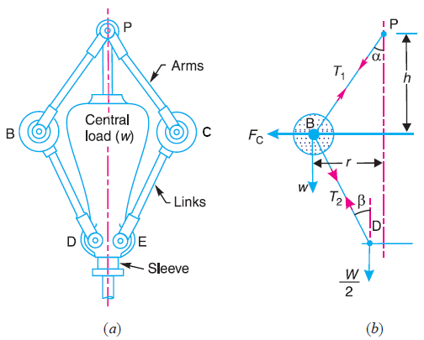Fig .3. Porter governor.
Let m = Mass of each ball in kg,
w = Weight of each ball in newtons = m.g,
M = Mass of the central load in kg,
W = Weight of the central load in newtons = M.g,
r = Radius of rotation in metres
h = Height of governor in metres ,
N = Speed of the balls in r.p.m .,
ω = Angular speed of the balls = 2 πN/60 rad/s,
F_{C} = Centrifugal force acting on the ball in newtons = m.ω².r,
T₁ = Force in the arm in newtons,
T₂ = Force in the link in newtons,
α = Angle of inclination of the arm (or upper link) to the vertical, and
β = Angle of inclination of the link (or lower link) to the vertical.
Though there are several ways of determining the relation between the height of the governor (h) and the angular speed of the balls (ω), the following two methods are used:
1. Method of resolution of forces ; and
2. Instantaneous centre method.
- Method of resolution of forces
Considering the equilibrium of the forces acting at D, we have
T₂ cosβ = $\frac{W}{2}$ = $\frac{M . g}{2}$
or T₂ = $\frac{M . g}{2 cosβ}$
Again, considering the equilibrium of the forces acting on B.
Σ F_{y} = 0
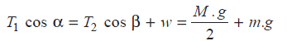 ………(1)
Σ F_{x} = 0
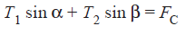
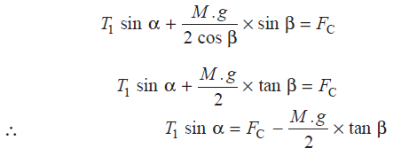 ……….(2)
Dividing equation (2) by equation (1),
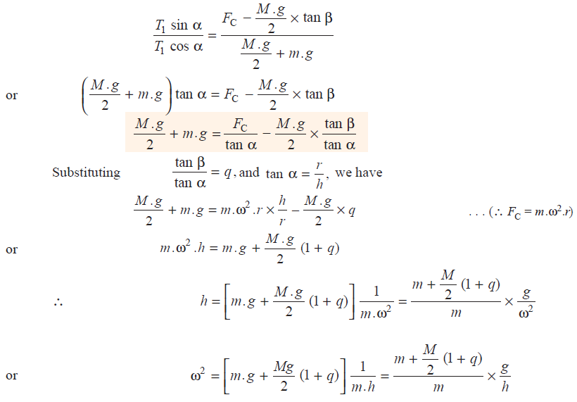
Notes : 1. When the length of arms are equal to the length of links and the points P and D lie on the same vertical line, then
tan α = tan β or q = tan α / tan β = 1
h = $\frac{m+M}{m}$ . $\frac{g}{{}^{2}}$
- When the loaded sleeve moves up and down the spindle, the frictional force acts on it in a direction opposite to that of the motion of sleeve.
If F = Frictional force acting on the sleeve
h = $\frac{m . g +\left(\frac{M .g ± F }{2} \right) (1+q)}{m }$ . $\frac{1}{{}^{2}}$
The + sign is used when the sleeve moves upwards or the governor speed increases and –sign is used when the sleeve moves downwards or the governor speed decreases.
- Instantaneous centre method
In this method, equilibrium of the forces acting on the link BD are considered. The instantaneous centre I lies at the point of intersection of PB produced and a line through D perpendicular to the spindle axis, as shown in Fig .4.
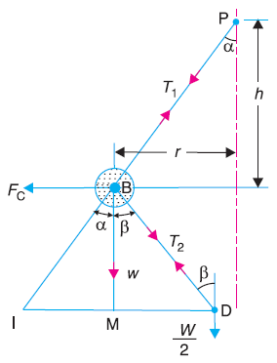
Taking moments about the point I,
F_{C} × BM = w × IM + $\frac{W}{2}$ × ID
= m . g × IM + $\frac{M . g}{2}$ × ID
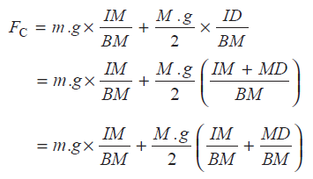
Fig .4. Instantaneous centre method.
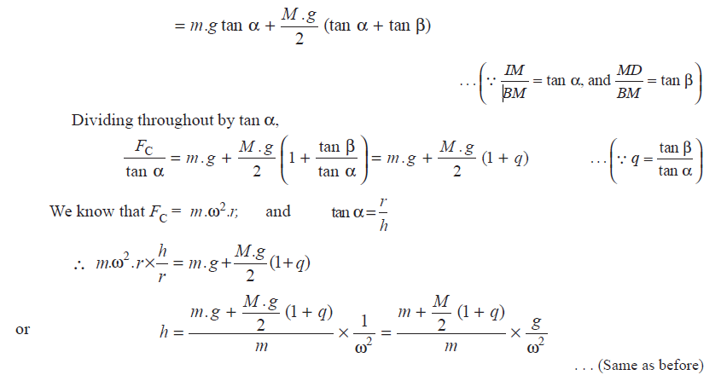
Example: 1 In an engine governor of the Porter type, the upper and lower arms are 200mm and 250 mm respectively and pivoted on the axis of rotation. The mass of the central load is 15 kg, the mass of each ball is 2 kg and friction of the sleeve together with the resistance of the operating gear is equal to a load of 25 N at the sleeve. If the limiting inclinations of the upper arms to the vertical are 30° and 40°, find, taking friction into account, range of speed of the governor.

Solution:
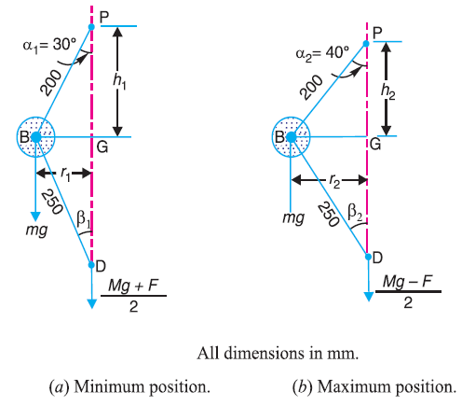
Minimum radius of rotation,
r₁ = BG = BP sin 30° = 0.2 × 0.5 = 0.1 m
Height of the governor,
h₁ = PG = BP cos 30° = 0.2 × 0.866 = 0.1732 m
DG = (BD)² – (BG)² = (0.25)² – (0.1)² = 0.23m
tan β₁ = BG/DG = 0.1/0.23 = 0.4348
tan α₁ = tan 30° = 0.5774
q₁ = $\frac{\tan{β_{1}}}{\tan{α_{1}}}$ = $\frac{0.4348}{0.5774}$ = 0.753
${{}_{1}}^{2}$ = $\frac{m . g +\left(\frac{M .g - F }{2} \right) (1+q_{1})}{m }$ . $\frac{1}{h_{1}}$
= $\frac{2 × 9.81 +\left(\frac{15 × 9.81 - 25 }{2} \right) (1+0.753)}{2 }$ . $\frac{1}{0.173}$
ω₁ = 19.2 rad/s
Maximum radius of rotation,
r₂ = BG = BP sin 40° = 0.2 × 0.643 = 0.1268 m
Height of the governor,
h₂ = PG = BP cos 40° = 0.2 × 0.766 = 0.1532 m
DG = (BD)² – (BG)² = (0.25)² – (0.1268)² = 0.2154 m
tan β₂ = BG/DG = 0.1268 / 0.2154 = 0.59
tan α₂ = tan 40° = 0.839
q₂ = $\frac{\tan{β_{2}}}{\tan{α_{2}}}$ = $\frac{0.59}{0.839}$ = 0.703
${{}_{2}}^{2}$ = $\frac{m . g +\left(\frac{M .g + F }{2} \right) (1+q_{2})}{m }$ . $\frac{1}{h_{2}}$
= $\frac{2 × 9.81 +\left(\frac{15 × 9.81 + 25 }{2} \right) (1+0.703)}{2 }$ . $\frac{1}{0.1532}$
ω₂ = 23.25 rad/s
Range of speed
= ω₂ – ω₁ = 23.25 – 19.2 = 4.05 rad/s Ans.
Proell Governor
The Proell governor has the balls fixed at B and C to the extension of the links DF and EG, as shown in Fig. 1(a). The arms FP and GQ are pivoted at P and Q respectively.
Consider the equilibrium of the forces on one-half of the governor as shown in Fig. 1(b). The instantaneous centre (I) lies on the intersection of the line PF produced and the line from D drawn perpendicular to the spindle axis. The perpendicular BM is drawn on ID.
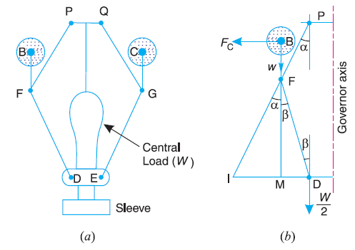
Fig. 1 Proell governor.
Taking moments about I,
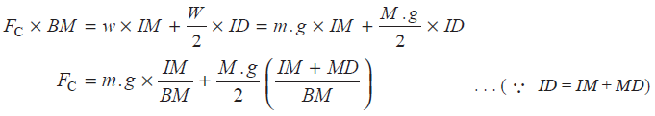
…… (1)
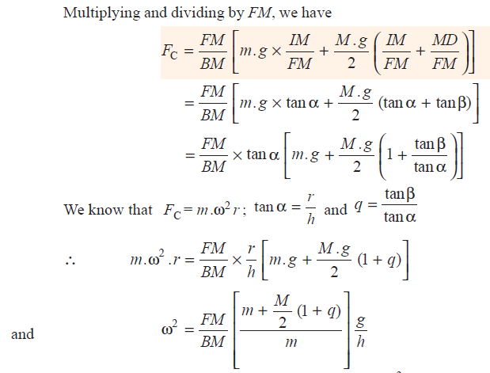
…... (2)
Note : When α = β, then q = 1. Therefore equation (2) may be written as
h = $\frac{FM}{BM}$ ( $\frac{m+M}{m}$ ) . $\frac{g}{{}^{2}}$

Example: 2
The following particulars refer to a Proell governor with open arms:
Length of all arms = 200 mm ; distance of pivot of arms from the axis of rotation = 40mm ; length of extension of lower arms to which each ball is attached = 100mm ; mass of each ball = 6 kg and mass of the central load = 150 kg. If the radius of rotation of the balls is 180 mm when the arms are inclined at an angle of 40° to the axis of rotation, find the equilibrium speed for the above configuration.
Solution:
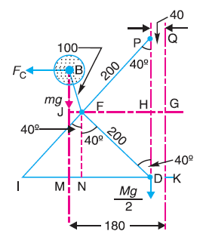
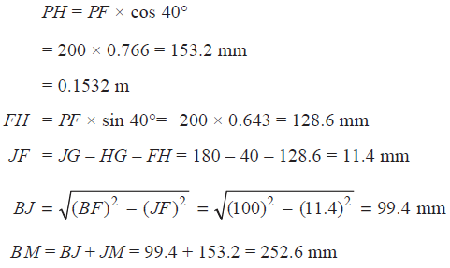
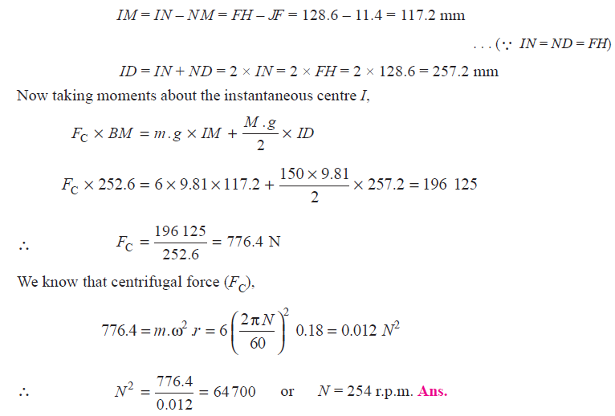

Home Work

A governor of the Proell type has each arm 250 mm long. The pivots of the upper and lower arms are 25 mm from the axis. The central load acting on the sleeve has a mass of 25 kg and the each rotating ball has a mass of 3.2 kg. When the governor sleeve is in mid-position, the extension link of the lower arm is vertical and the radius of the path of rotation of the masses is 175 mm. The vertical height of the governor is 200 mm. If the governor speed is 160 r.p.m. when in mid-position, find: 1. length of the extension link; and 2. tension in the upper arm.

Answers :
- BF = 108 mm
- T= 192.5 N

